THRIFTWOOD COLLEGE
Improvement Plan Summary 2015-16

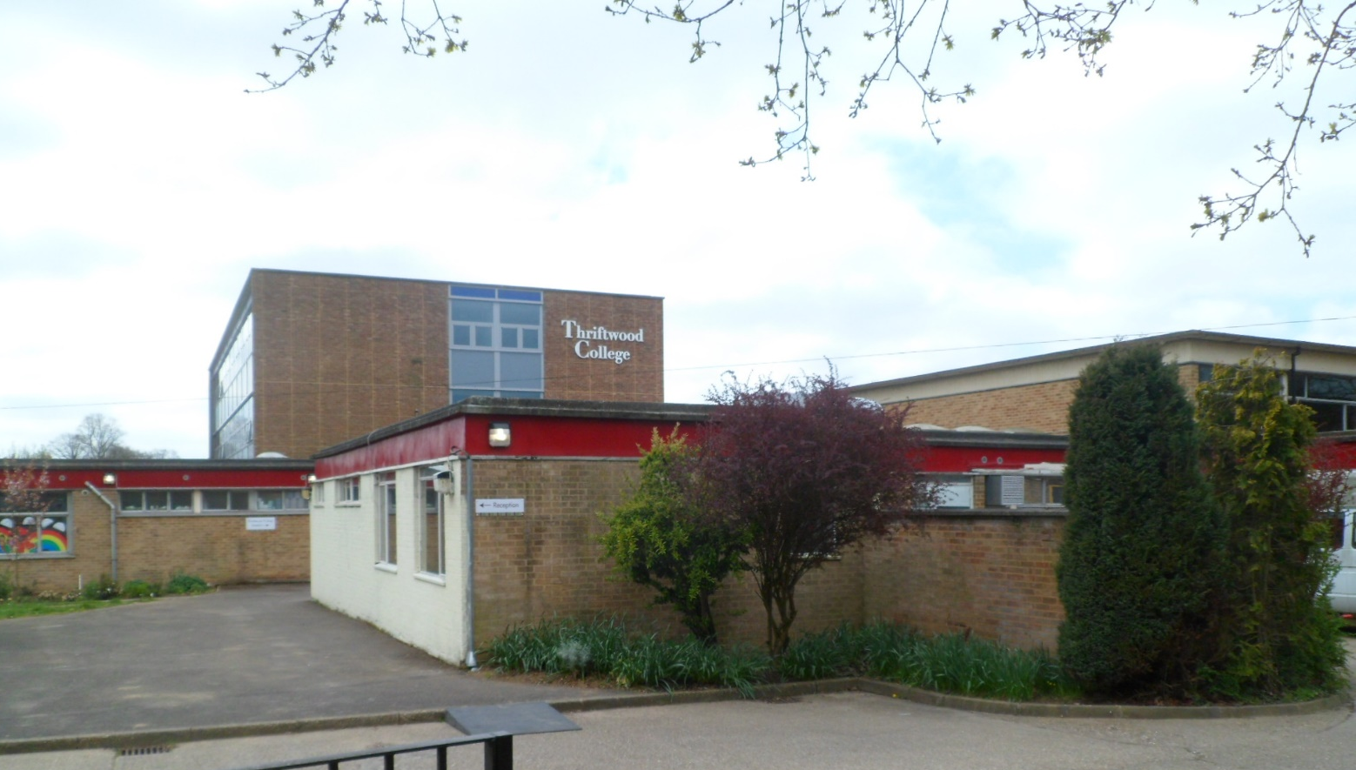

Information for Parents and Carers
The complete School & College Improvement Plan can be found on our website www.thriftwoodschool.com

Please read about some of the aspects of college development on which we are focused this year….

Communicating with Parents
We are beginning to use more ways to communicate with parents.
These include:
- Emails
- Texts
- Information Evenings
- Updates on the School/College Website

Let us know other ways to keep you informed and how we may best keep in touch with you.
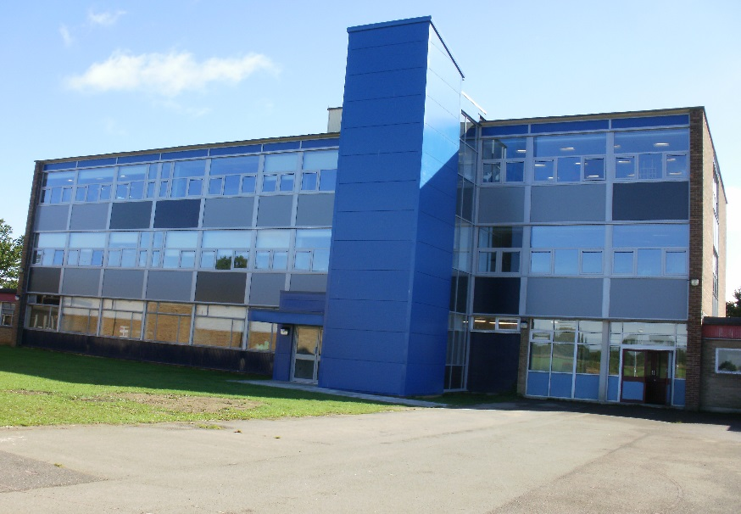

The refurbished college building and the striking ‘blue lift’, which is now well used by students. Completed Spring 2015.

The Big Read
One of our key aims this year is to stimulate all students to continue reading. We want to enthuse everyone so that at least 80% of our students will make progress in their reading.
We would still appreciate any donations of good quality books

Education Health Care Plan Transfer Reviews
This is a big task for us this year, transferring Statements to E.H.C.Ps. Please ensure that you attend your son/daughters review this term if you are required. Please also fill in the paperwork you are sent carefully as this is your opportunity to express your wishes for the future.
Any questions, please contact Alison Carmichael on 01245 262 779
New leisure options for students including street dance with Nina. September 2015.

Health, Safety and Well Being
- We are promoting our new lunches at college – there are now well balanced and nutritious hot and cold options. We would appreciate feedback from parents and carers about this service.

- We are developing a café on site in order to provide more options for our students.

- Helping students to make safe choices in life is an important aspect of the curriculum this year.

Please contact Mary Booker on 01245 262 779 if you would like more details regarding aspects of health and well-being.
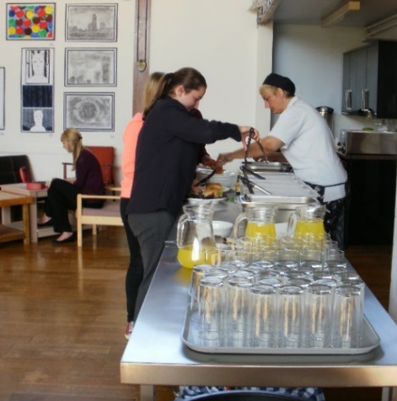
New provision for hot and cold healthy College lunches. September 2015.

Important Dates for your Diary
Wednesday 7th October 6.30–8.00pm Presentation Evening at College
Thursday 26th November 10.00am-12.00pm 40th Birthday Open Morning
Thursday 10th December 7.00-9.00pm Open Mic Night

Contact Points
Please call the College for all enquiries on 01245 262 779
Mrs Smart, Head of College, and Mrs Davies, Principal, will be available via the admin email on: college@thriftwoodschool.com
or the College telephone number above.

For all queries regarding your child, please contact:
- Jon Hutchings – Head of Key Stage 5
- David Hutton – Head of Key Stage 4
- Janine Cavey – Home School Liaison Manager

Administration Team
- Lisa Fossey – Receptionist
- Gemma Baker – Office Administrator
- Lisa Baines – Office Manager

