Learn to Sail in 2021
RYA On Board

Grangewaters is the perfect environment to learn to sail with our expert RYA instructors, an extensive training fleet and all the safety equipment provided. Complete the internationally recognised course and gain Royal Yachting Association qualifications giving you the independence and confidence to enjoy this exciting sport.

Grangewaters has been awarded Sport England funding to Tackle Inequalities through RYA (Royal Yachting Association) sailing activity. We are excited to be offering this fully funded sailing course to SEND Schools and recognised SEND groups. For more details about the two day programmes and to check your young person’s eligibility please contact the centre.

Dates | Times
Tues 27th -Wed 28th July | 09:30 – 16:00
Mon 2nd - Tues 3rd Aug | 09:30 – 16:00
Thurs 12th - Fri 13th Aug | 09:30 – 16:00
Tues 17th - Wed 18th Aug | 09:30 – 16:00
Thurs 26th – Fri 27th Aug | 09:30 – 16:00
Tues 31st Aug - 1st Sept | 09:30 – 16:00
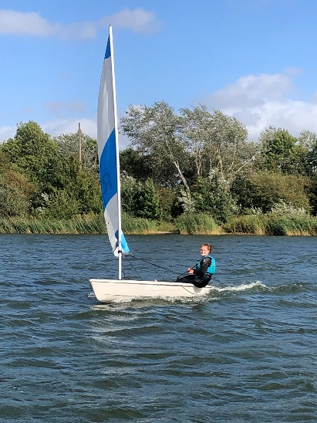

The course is aimed at adults and children age 12+ who will sail solo or with a member of their household or care bubble. All bookings per 2-day course must be made in advance by phoning our reception 01708 855228.

“Sailing is one of the most exciting and interesting sports to learn and has always been a passion of mine”. Will Kennedy – RYA Senior Instructor & Grangewaters Instructor.

