Pupil Voice Survey Summary - February 2026

Overview
In February 2026, we gathered pupil voice responses to understand pupils' views on college life, including safety, accreditation, dress expectations, rewards, behaviour systems, lunch provision, and Year 11 transition intentions.
A total of 91 pupils responded across Key Stage 4 and Key Stage 5.
Group | Responses | Notes
Year 10 | 27 | KS4
Year 11 | 30 | KS4
Year 12 | 11 | KS5
Year 13 | 23 | KS5
KS4 total | 57
KS5 total | 34

Headline findings
- Most pupils said they feel safe at college (95%).
- Most pupils said they understand dress expectations for their key stage (96%).
- Most pupils felt there are appropriate consequences for poor behaviour (76%).
- Views on the new lunch setup were mostly positive or neutral, with comments focusing mainly on general impressions and food quality.
- Accreditation awareness was more mixed (53% said yes).

At-a-glance charts
The two charts below highlight one strong headline measure (safety) and one area where pupil understanding is more mixed (accreditation awareness).
Figure 1. Pupil responses to 'Do you feel safe at college?'
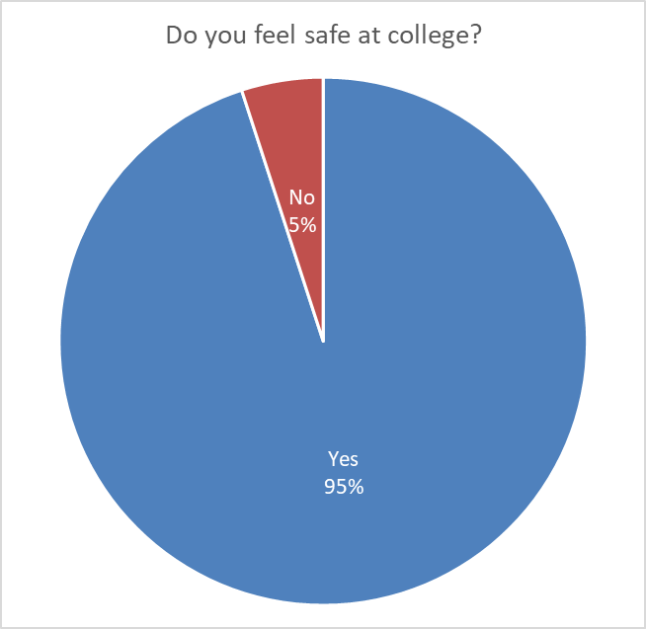
Yes: 86 | No: 5 (91)
Figure 2. Pupil responses to 'Do you know what accreditation you are working towards?'
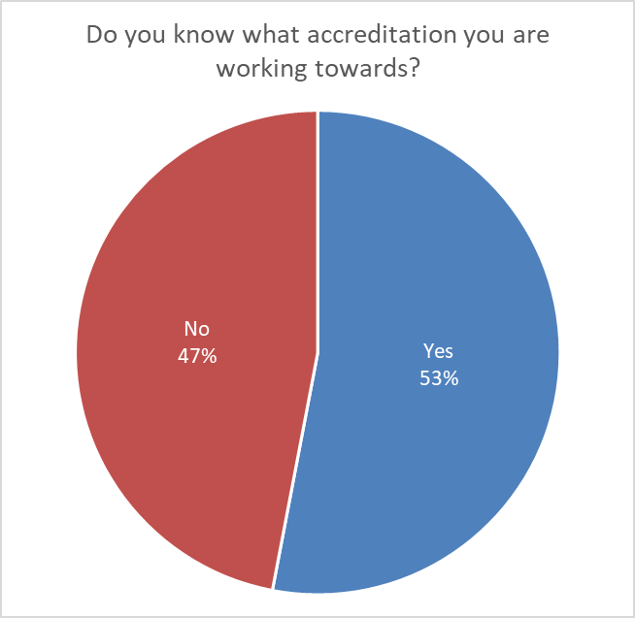
Yes: 48 | No: 43 (91)

1) Safety and wellbeing
Pupils were asked whether they feel safe at college. 86 pupils answered Yes and 5 answered No. This is a strong overall result and suggests that most pupils feel secure in the college environment.

2) Accreditation awareness and interests
Responses to accreditation awareness were more evenly split. 48 pupils said they know what accreditation they are working towards, while 43 said they do not. This suggests there may be value in continuing to reinforce what pupils are working towards and how it links to their next steps.
When asked about additional accreditations, many pupils either made no request or gave very brief responses. Where pupils did suggest ideas, the most common areas included academic subjects, sport, and employability/work-related interests. A small number of vocational interests were also mentioned.

3) Uniform and dress expectations
Dress expectations were one of the clearest areas of confidence in the survey: 87 pupils said they know what they should be wearing for their key stage, and 4 said they do not.
Open responses about the value of KS4 uniform and KS5 non-uniform were often short, but several themes came through: structure and consistency in KS4, growing independence in KS5, and the idea of looking smart and ready for college. Many pupils used brief comments such as 'fine' or similar, which is typical in pupil voice responses.

4) Rewards and behaviour
On behaviour systems, 69 pupils felt there are appropriate consequences for poor behaviour, while 22 did not.
Responses about praise and rewards were mixed. Many pupils appeared satisfied with current rewards, while others suggested more tangible rewards or activities. A smaller number of responses focused on recognition and praise rather than material rewards. These comments are useful for ongoing review, while being interpreted alongside staff judgement and day-to-day context.
When asked about other consequences, many pupils did not suggest any additional approaches. Where suggestions were made, they commonly referred to detention/timeout-type responses or loss of privileges.

5) Lunch provision
Feedback on the new college lunch setup was mostly positive or neutral. 53 responses were coded as positive, 33 as neutral/unclear, 2 as negative, and 3 were not applicable (for example, pupils who do not use college lunch).
The strongest theme in lunch comments was general opinion (for example, short responses such as 'good' or 'fine'). The next most common theme related to food quality. A smaller number of pupils mentioned choice/variety, queueing/speed, or the dining environment.

6) Year 11 transition intentions
For Year 11 pupils only (30), 7 pupils gave a clear indication that they are considering leaving, and 23 did not give evidence that they are considering leaving.
Within the small group considering leaving, the most common reason was a desire for a change or greater independence. Because the group is small, these responses are most useful as an internal prompt for discussion rather than a broad conclusion.

Summary
Overall, the survey presents a positive picture, particularly around safety and understanding of dress expectations. Behaviour systems and lunch provision were also broadly positive, while accreditation awareness was more mixed. As with all pupil voice work in a SEND setting, these findings are most useful when considered alongside staff knowledge, daily practice, and wider college information.

How this feedback will be used
This feedback will support ongoing review of curriculum communication, pupil experience, and college routines. Pupil voice remains one important source of information, and it will continue to be considered alongside staff expertise and wider college evidence when shaping future development.

