What the frack?

When you hear the words 'the environment', what do you think of? Do you picture colourful laminated pictures of the Earth that used to festoon the walls of a display in your primary school? Do you think about some emaciated-looking polar bear balancing for dear life on an ever-shrinking iceberg? Do you think of litter picking in the park? Turtles swimming in a sea of plastic bags? A nice picnic somewhere green? The hassle of sorting out the recycling?

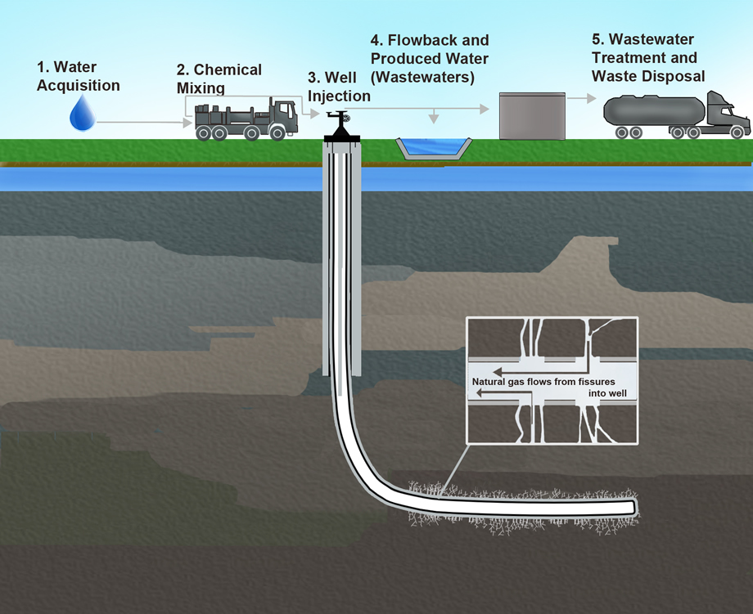
The truth is, most of us are rubbish when it comes to understanding the environment and our own impact on it. We tend to think of the environment as some far-off, notional thing that mostly exists elsewhere and is only of interest if you're a) old or b) not into washing. Yet in reality, the environment is our Earth; it's everywhere around us. It's what sustains us and keeps us alive; it's the air that we breathe; it's the water that we drink; it's the food that we eat.

And we're killing it.

I'm not exaggerating when I say we're killing the Earth; we humans have caused the extinction of 60% of animal populations since 1970. Half of the Great Barrier Reef, a life-sustaining ecosystem and one of the most beautiful natural wonders in the world, has now been bleached to death thanks
to human-caused climate change. Scientists are predicting that intense over-farming methods have left us with only 60 more years of fertile soil at the current rate of degradation.

If this sounds like doom and gloom: it is. We need to wake up to the reality of the harm we're doing to the environment, before it's too late. We're already on course to see the Earth's temperature rise by 2 degrees, which itself will cause food shortages, water shortages, and may destroy cities.

You may be thinking, it's the government's responsibility to sort this out. And you'd be right. But the government can't be relied upon to take the action necessary for the long-term benefit of the planet, especially when there's short-term profit to be made. Take fracking, for example; the environmental harms of this practice are well documented, but the government has ignored the protests of anti-fracking demonstrators and councils who did not want fracking in their area. “Shale gas has the potential to power economic growth,” the Communities Secretary, Sajid Javid, was reported as saying at the time. Quite where we're supposed to put all this money when the planet's dead he didn't mention.

The same myopic approach can be seen in the approach of governments towards industries and corporations responsible for mass pollution. The meat and dairy industries are on track to surpass the oil industry as the world's biggest polluters in 2018. The transport industry is responsible for 15% of global CO2 emissions. Do you trust the governments of the world's countries to stand up to these corporate colossi? Putting pressure on our leaders to preserve the planet for future generations may well be the difference between life and death.

We can protect our environment for future generations, or we can sit back and claim we didn't know what's going on. The choice is ours.

And future generations will judge us by it.

Challenging

- Name FOUR facts you learn about the environment in this text.
- How many rhetorical questions are used in this text? How do they help to make the text effective?
- Find THREE examples of opinion stated as fact. How do they help to make the text effective?
- How has the writer structured the text to interest you? Hint: Look at the beginning and the end of the text.

More Challenging

1. Name FOUR facts and ONE thing you infer about the environment from this text.

2. Name FIVE techniques used by the writer in this text. For each technique, give a quote from the text and explain its effectiveness.

3. Name THREE structural features used in this text. For each structural feature, explain how this adds to the effectiveness of the text.

Mega Challenging

1. Name FOUR facts about the environment and THREE things you infer from this text.

2. Name EIGHT techniques used by the writer in this text. List them in order of effectiveness. For each technique, give a quote from the text and explain why you have placed it in that order.

3. Name FIVE structural features used in this text. List them in order of effectiveness. Feach structural feature, explain how this adds to the effectiveness of the text.

