Maths Activity Booklet

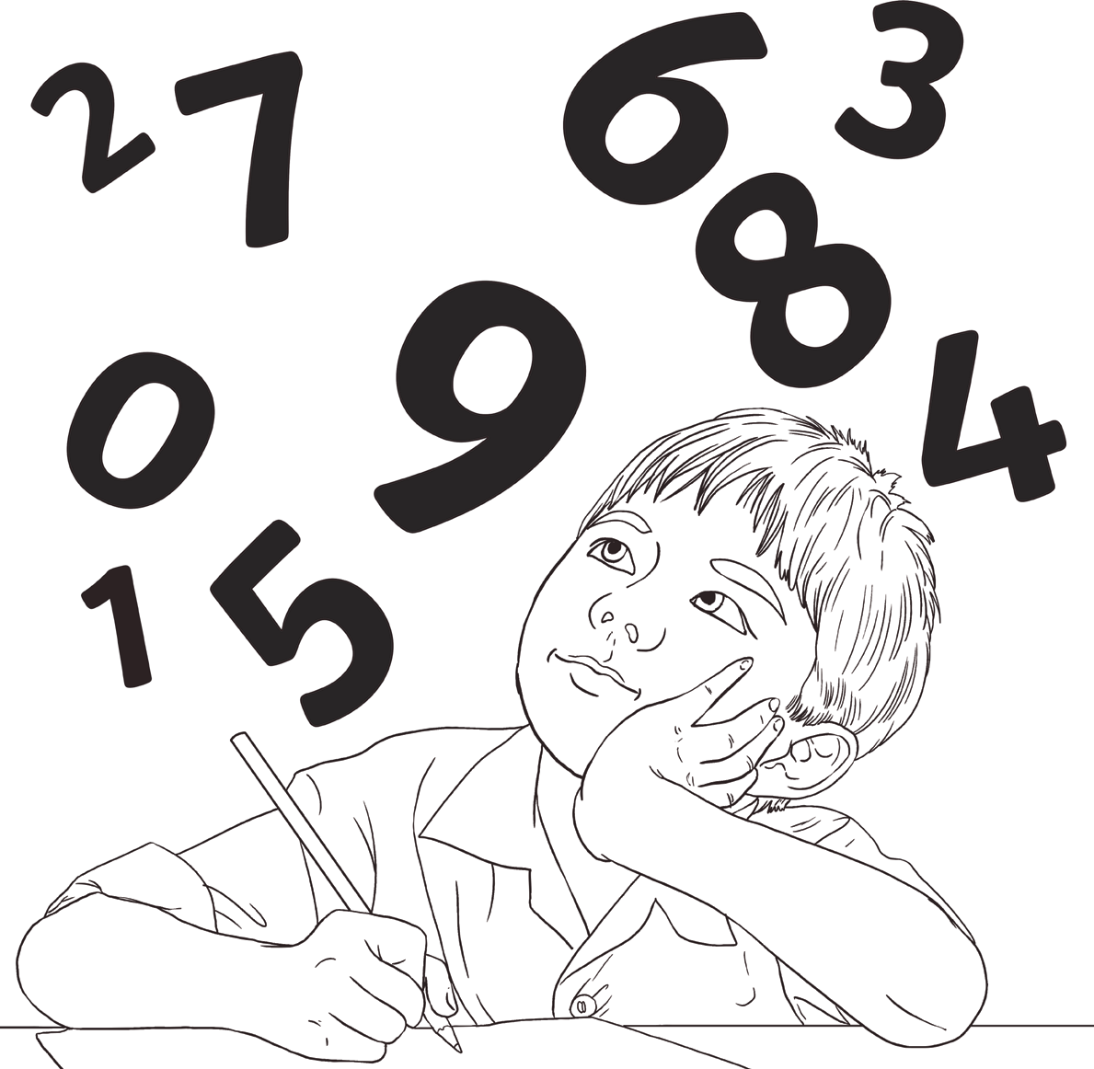

Number and Place Value

- Continue these number sequences:
9, 18, 27, 36, 45, , , , , , , ,
775, 750, 725, 700, , , , , , , ,
5, 4, 3, 2, , , , , , , ,
- Find 100 less than these numbers:
3912
9201
1083
- Find 1000 less than these numbers:
59 003
17 351
20 882
- What is the value of the underlined digit in each number?
1846
2004
1589
- Put these numbers in order from smallest to largest.

10 111 | 11 011 | 10 011 | 11 110 | 11 101
Smallest |  |  |  | Largest

- Compare these numbers using <, > or =.
454 544 660 606 2 tens 4 ones 24 ones

Representing Number

- What number is shown below?
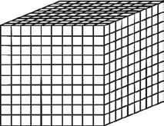
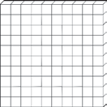

- Complete the table, showing the numbers in numerals and words.

2109
One thousand, two hundred and
ninety-three.
29 431
Seventy-five thousand and
ninety-eight.

- Use the information in the table to work out the value of these Roman numerals.
Roman | Numeral
I | 1
V | 5
X | 10
L | 50
C | 100

LXXII = XIV = CCLIX=

- a) What is the largest number that can be made from these digit cards?
2
7
6
b) What is the smallest number that can be made from
these digit cards?
5
9

Addition and Subtraction

- Complete these calculations mentally:
421 + 50 =
376 + 200 =

250 - 99 =
- Complete these calculations:
 | 1 | 3 | 5 | 7
+ | 2 | 6 | 4 | 1

 | 3 | 5 | 9 | 2
+ | 4 | 2 | 3 | 8

 | 7 | 9 | 8 | 5
- | 1 | 3 | 4 | 2

 | 5 | 3 | 1 | 9
- | 3 | 2 | 6 | 7

- Complete these calculations:
3410 + = 5655
6720 – = 5220
- Use appropriate calculations to solve these problems.

- At a cinema, there is room for 750 people in a screen. If the cinema sells 641 tickets for a screen, how many are left?

- In one day, 2345 people visit the cinema. 1032 of them go and see an action film and the
others go and see a comedy. How many people went to see the comedy?

Multiplication and Division

- Fill in the missing numbers in the multiplication square.

x | 1 | 2 | 3 | 4 | 5 | 6 | 7 | 8 | 9 | 10 | 11 | 12
1 | 1 | 2 |  | 4 |  | 6 |  | 8 | 9 |  | 11 | 12
2 | 2 |  | 6 | 8 |  | 12 | 14 |  | 18 | 20 |  | 24
3 | 3 |  |  | 12 | 15 |  | 21 | 24 |  | 30 | 33
4 |  | 8 | 12 |  | 20 | 24 |  | 32 | 36 |  | 44 | 48
5 | 5 | 10 |  | 20 | 25 |  | 35 | 40 |  | 50 | 55
6 | 6 |  | 18 | 24 | 30 | 36 |  |  | 54 | 60 |  | 72
7 |  | 14 | 21 |  |  | 42 | 49 | 56 |  | 70 | 77
8 | 8 | 16 |  | 32 | 40 |  | 56 | 64 | 72 |  | 88 | 96
9 |  | 18 | 27 |  | 45 | 54 | 63 |  | 81 | 90 | 99 | 108
10 | 10 |  | 30 | 40 |  | 60 | 70 | 80 | 90 | 100 |  | 120
11 |  | 22 | 33 |  | 55 | 66 |  | 88 |  |  | 121
12 | 12 | 24 |  | 48 | 60 |  | 84 |  | 108 | 120 |  | 144
- Explain the pattern of the 9 times table.

Multiplication and Division
- Complete these calculations:
250 × 4 =
555 × 100 =
2540 × 0 =

- Use your knowledge of multiplication and division methods to solve these problems.
  - A box of glue sticks contains 128 glue sticks. There are 4 classes in the school. How many
glue sticks does each class get?

  - To make a model, each child needs 8 lolly sticks. If lolly sticks come in packs of 30, how many packs would be needed for 28 children to make a model?

- Use formal methods to complete these calculations.
a) 45 × 6 = b)333 ÷ 9 =

- If we know that 12 × 13 = 156, what other calculations do we know? Write them below.

- Fill in the missing numbers.
× 12 = 132 125 ÷ = 5

8 × = 120 ÷ 7 = 50

Fractions
- Continue the number sequences.

2 3 4 5

10 ,10 , 10 , 10 ,

56 54 52 50
100 , 100 ,100 ,100,

- Find 6
8
of these bananas.

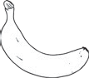

- a) What fraction of the shape is shaded?

b) Write 2 equivalent fractions to the amount shaded.

Fractions
- Use the fraction wall to help you answer these questions.

1
1  3 |  |  |  |  |  |  |  | 1  3 |  |  |  |  |  |  |  | 1  3
1  6 |  |  |  | 1  6 |  |  |  | 1  6 |  |  |  | 1  6 |  |  |  | 1  6 |  |  |  | 1  6
1  12 |  | 1  12 |  | 1  12 |  | 1  12 |  | 1  12 |  | 1  12 |  | 1  12 |  | 1  12 |  | 1  12 |  | 1  12 |  | 1  12 |  | 1  12
1  24 | 1  24 | 1  24 | 1  24 | 1  24 | 1  24 | 1  24 | 1  24 | 1  24 | 1  24 | 1  24 | 1  24 | 1  24 | 1  24 | 1  24 | 1  24 | 1  24 | 1  24 | 1  24 | 1  24 | 1  24 | 1  24 | 1  24 | 1  24

- How many sixths are equivalent to 2
3

- How many twelfths are equivalent to
?
6
24 ?
5

- How many twenty-fourths are equivalent to 6 ?

- Would you rather have 7
12
or 15
24
of a cake? Why?

- Complete these calculations:

1 + 3
10 10 = =
3 + 4
8 8 =
7 – 2
9 9 =
4 – 1
6 6 = =

- Put these fractions in order from smallest to largest.

3 2

6 3

Smallest
1 2

10 8
5

6

Largest

Fractions and Decimals
- Match the decimal to its equivalent fraction.

1
2
1
10
3
4
6
10
1 100

0.01

0.6

0.5

0.1

0.75

- Complete the table. One has been done for you.

 | ÷ 10 | ÷ 100
13 | 1.3 | 0.13
42
68
3
- Round these decimals to the nearest whole number.

1.2
5.6
2.21
3.5
1.55

- Compare these decimals using <, > or =.
0.5 0.05 1.02 1.020 3.75 3.775

Measurement
- a) Measure this line using a ruler. Write its length in cm and in mm.

=
  - Use a ruler to draw a line that measures 53mm.

- Write the amount shown on each scale.
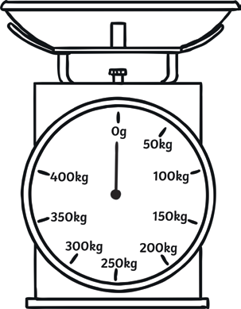
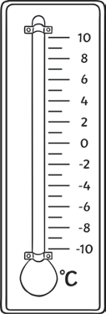
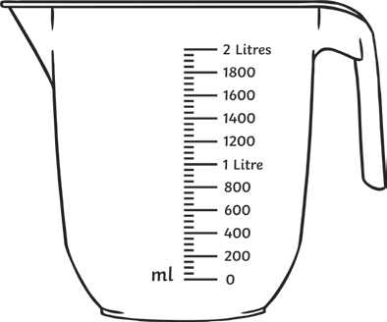
450kg

kg °C ml

- Convert these units.

a) 1500g = kg

b) 2450g = kg

c) 1.75m = cm
    - 12.5cm = mm

    - 1.2km = m

f) 2300ml = l

- Anna says five 750ml bottles will hold more than three 1l bottles. Is she right? Explain
how you know.

Area and Perimeter
  - Calculate the perimeter of this shape.

9cm

3cm
6cm

6cm

3cm

Perimeter = cm

  - What is the area of this shape?

Area = cm3

Area and Perimeter
  - Which of these shapes has the largest area? Circle the shape below.

- Write the time these clocks show.

Time

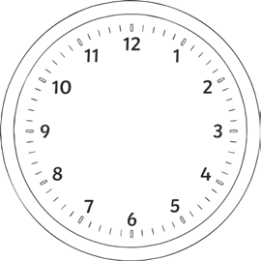

- Draw the hands to show the given time on each clock.

1:15 or quarter past 1 4:50 or ten to 5 7:45 or quarter to 8

- A film lasts for 165 minutes. How long is the film in minutes and hours?

- Complete the sentences.

There are seconds in 1 minute. There are minutes in 1 hour.
There are hours in 1 day. There are days in 1 week. There are days in 1 year. There are months in 1 year.
- How many days are in June?

Shape
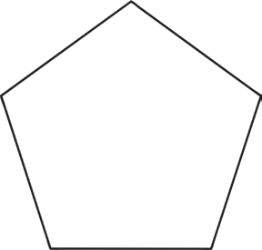
- Name these 2D shapes.

- Name these 3D shapes.
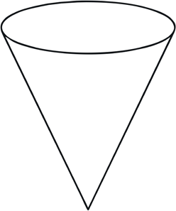
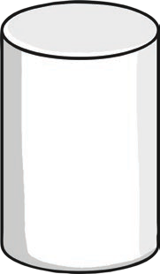
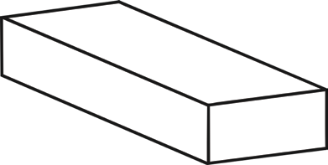
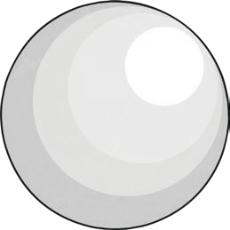
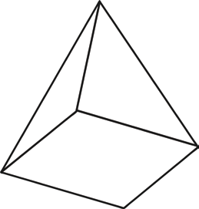

Shape
- Draw the following shapes in the correct places on the Venn diagram.
  - square
  - right angled triangle
  - pentagon
  - parallelogram
e
s
r
i
i
d
g
e
h
s
t
a
n
g
l
e
H
a
s
a
t
l
e
a
s
H
t
a
o
s
n
4

- Match the type of triangle to its definition.

Equilateral |  |  | One angle is a right angle
Isosceles |  | Al | l sides and angles are equal
Scalene |  |  | 2 sides and angles are equal
Right-angled triangle |  |  | No sides or angles are equal

Angles
- Order these angles from smallest to largest.

A | B | C | D

- Tick all the shapes that have obtuse angles.

Symmetry
- Draw a line of symmetry on these shapes.

- Reflect the shapes in the mirror line.

Position and Direction
- Write the coordinates for the points marked on the grid.

5
A
B
C

4
A
3
B

2 C

1

0 1 2 3 4 5

- Plot these coordinates on the grid. What shape is made?

(0, 2)

5
4
3
2
1
0 | 1 | 2 | 3 | 4 | 5

(1, 4)

(4, 2)

(5, 4)

Position and Direction
- Translate this triangle 2 squares to the right and 3 squares up. Label this new triangle B.
A

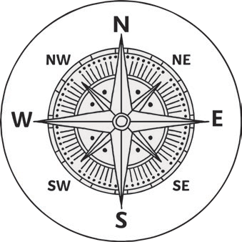
- Amy is walking north east. She turns quarter of a turn anticlockwise. What direction is she walking now?

- Simon left his house and turned right. He made a right turn at the next junction and right at the junction after. Where is Simon?

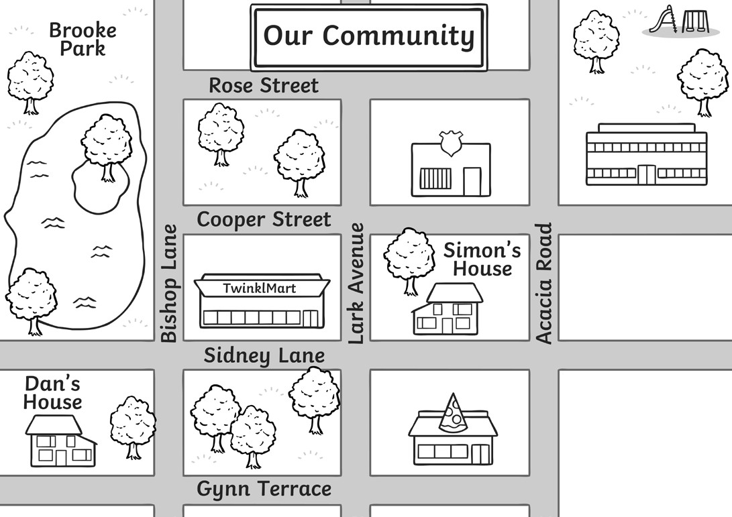
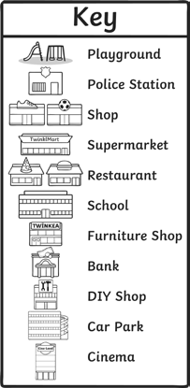

Statistics
- A class were asked to choose their favourite animals. These were the results:

Animal | Tally
Cat
Dog
Panda
Giraffe

12
10
8
6
4
2
0 Cat

Dog Panda Hippo Giraffe

- Use the information in the bar chart to complete the information in the table.

- Add the information for ‘Dog’ to the bar chart.

- Which was the most popular animal?

- Which animal was half as popular as a dog?

- How many children were asked in total?

Statistics
- A school measured the heights of all children. The results are shown in the graph below.

The Height of Children
25

20
Number of Children

15

10

5

0
80cm - 89cm
90cm - 99cm
100cm - 109cm
110cm - 119cm
120cm - 129cm

Height in cm

- Which height was the least common in the school?

- How many children measured less than 1m?

- 3 more children joined the school who measure between 110cm – 119cm. Add this information
to the graph.

- After these children joined, how many children were measured in total?

