Maths Level – Yellow Entry Level 2/3
Topic: Division
AIM: To be able to understand how to divide numbers using the ‘bus stop method’ and use this method to solve word problems.
How to guide:
Division is splitting into equal parts or groups.
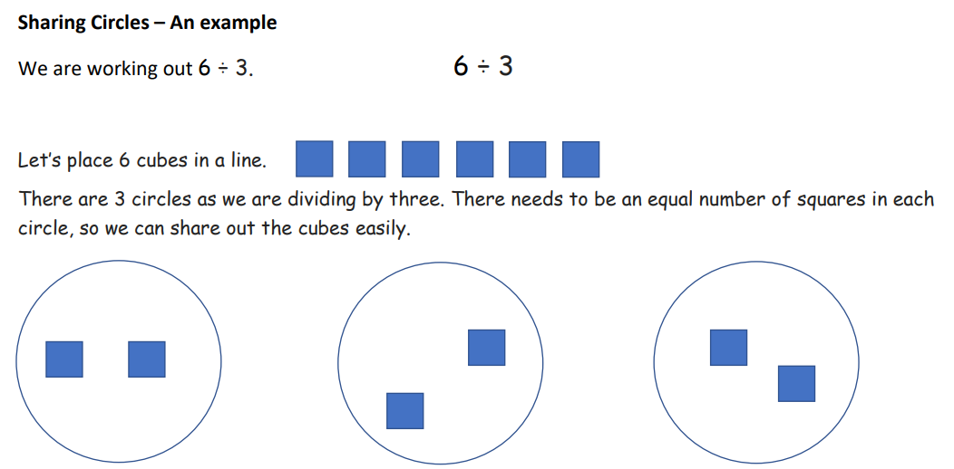

Division is also the inverse operation to multiplication
Example 1: 5 x4 = 20 if we invert this is looks like 20 ÷5 = 4

Example 2: 3 x 2 = 6
2 x 3 = 6
6 ÷ 3 = 2
6 ÷ 2 = 6
You can see that all the same numbers have been used.

Practice these questions using your knowledge of times tables
- 5 x 6 = __
__ ÷ 5 = 6

- 10 x 3 = __
__÷ 10 = 3

- 4 x 7 = __
__ ÷ 7 = 4

- 2 x 12 =__
__÷ 12 = 2

- 9 x 3 = __
__ ÷ 9 = 3

Now that you have a technique for division complete these questions

How to guide:
Follow this step by step guide on how to do bus stop method.
Watch this video to help to see some examples Mr Smith Maths Bus Stop Division - YouTube
Example 1: 145 ÷5 =
How many fives are there in 1?
There are no fives in 1, so you write a 0 above the five
How many are left over?
There was 1 left over so you write that next to the four.
How many fives are there in 14?
There are two fives in 14, (5 x2 = 10) so you write the 2 above the four.
How many are left over?
There is four left over so you write four next to the five.
How many fives are there in 45?
There are 9 fives in 45 (9x5 = 45). So you write the 9 above the five.
The answer is 145 ÷5 = 29
Use the methods above to solve these questions.
69 ÷ 3 = | 88 ÷ 4
46 ÷ 2 = | 24 ÷ 2 =
55 ÷ 5 = | 36 ÷ 3 =
70 ÷ 7 = | 99 ÷ 9 =
23 ÷ 1 = | 100 ÷ 10 =

Now try these harder questions using bus stop method

Now using the bus stop method solve this word problems.

