Maths Level – GREEN Higher (Functional Skills Level 1/2)
Topic: Time/Date
Aim: To correctly solve problems requiring calculations with time
Session 1 | Length of session: 40minutes
Aim of session: To correctly calculate the time word problems

Important information:
When the minute hand moves from one number to the next, it’s been 5 minutes

There are two hands on a clock:
Minute hand - long hand goes round quickly and measures minutes. When it goes round the clock once that is one hour
Hour hand - short hand goes round slowly and measures hours. When it goes round the clock once, it has been 12 hours
How to Guide:
kaldsadsa
5 minutes
10 minutes
15 minutes
I put the pizza in the oven at 20 minutes
past 5. It takes 15 minutes to cook. What
time do I take it out of the oven?
I find looking at a clock and adding the time on in five minutes helps me….

ANSWER: 35 minutes past 5
ANSWER: 25 minutes to 6
ANSWER: 5:35
ANSWER: 17:35

All are correct. The answer can be written different
but are all the same time

Starter :

- Sam went for a 15-minute run around the park. She stopped running at 25 minutes past 3. What time did she start running?

- The doctor saw a patient at 25 minutes past 2. She spent 25 minutes with them. What time was the appointment over?

- Jim woke up at 5 minutes past 5. He was awake for 15 minutes. At what time did Jim fall back to sleep?

- Peter practised playing the piano for three quarters of an hour. He started practising at 5 to 7. What time did he finish?

Activity :

- Your neighbour began her run at 8:00am. She ran for 45 minutes. She walked for a further 20 minutes. At what time did she finish her exercise?

- Alex painted from 9:40am until 10:20pm. How long did she spend painting?

- Your brother practised karate for 2 hours and 15 minutes. He finished practising at 6:05pm. What time did he begin?

- Sasha watched a film that lasted for an hour and 45 minutes. If the film ended at 2:55pm, when did it start?

- Ryan went to the cinema to watch a film. It started at 3:15pm and ended at 5:25pm. How long was the film?

- Marcus took 2 hours and 46 minutes to finish his chores. If he began at 4:51pm, when did he finish?

- Edward needed 25 minutes to bake some cookies and 50 minutes to bake some brownies. If he began baking at 7:30pm, when would he finish?

- The film Zootroppolis is 108 minutes long.
a. How many hours and minutes is that?

b. If the film starts at 14:25, when does it finish?

Extension: Now log onto your MyMaths and complete any online homework

Maths Level – GREEN Higher (Functional Skills Level 1/2)
Topic: Time/Date
Aim: To correctly solve problems requiring calculations with time
Session 2 | Length of session: 40minutes
Aim of session: To correctly identify the time measurement required to answer varying time questions.

Important information:

There are 60 minutes in an hour

There are 60 seconds in a minute
How to Guide:
It is important to convert all the time in the questions to the same measurement; seconds, minutes or hours.

It takes me 33 seconds to eat an ice cream but my sister 1 min 5 seconds. How much quicker am I?

Me : 33 seconds

Sister : 1 min = 60 + 5 seconds = 65 seconds

65 - 33 = 32 seconds

ANSWER: I am 32 seconds quicker than my sister

Starter :

Activity :

- What is 513 minutes in hours and minutes?

- How many seconds are there in 4 minutes and 37 seconds?

- Rewrite three hundred and eighty-six minutes in hours and minutes.

- A film starts at 15:25 and lasts 132 minutes. What time will it finish?

- Cassie trains for 2 hours 30 minutes this week for a race. Charlie trained for 185 minutes. How trained for the longest?

- Below is a table with how much time four friends ran for on each of 4 days:
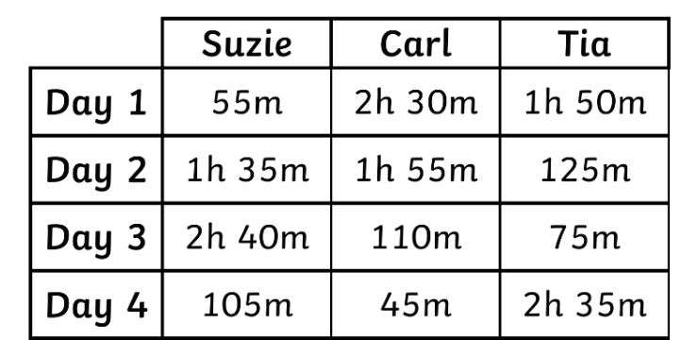

Who completed the most training and for how much longer than the other two friends?

- A sleeper train is due to leave at 23:25 and arrive the following day at 07:17. It leaves 12 minutes late but catches up time to arrive 3 minutes early. How long did the train take in hours and minutes?

- A swimmer swims 12 lengths of a swimming pool in 10 minutes and 36 seconds. On average, how long did each length take to swim?

Maths Level – GREEN Higher (Functional Skills Level 1/2)
Topic: Time/Date
Aim: To correctly solve problems requiring calculations with time
Session 3 | Length of session: 40minutes
Aim of session : To correctly identify and manipulate periods of time that are longer than a day

Important information:

There are 7 days in a week

There are 24 hours in a day

How to Guide:
It is important to convert all the time in the questions to the same measurement; seconds, minutes or hours.

Steve walks 5km every day. How many days will it take him to walk a total of 91km?

5km = 1 day / 10km = 2 day / 15km = 3 days (this will take too long, I see the pattern. Every day we add on 5km or x the day number by 5 therefore…)

91km ÷ 5km = 18.2 days

18 days walking 5 km = 18 x 5 = 90km (not enough km)
19 days walking 5km = 19 x 5 = 95km (more than total but makes Steve hit his target)

ANSWER: It will take Steve 19 days to reach 91km

Starter : Convert these times into their opposite am or pm

24-Hour Time | 12-Hour Time
03:15
 | 4:00pm
 | 7:30am
18:45
14:30
 | 5:30am
 | 10:45pm
17:30
09:15
 | 6:30am
22:30

Activity :

- An online company promises delivery within 72 hours. How many days is that?

- Medicine needs to be taken once every 6 hours. How many days will 32 tablets last?

- How many days are there in 18 weeks and 5 days?

- A year 12 class has 5 maths lessons during the week. Each lesson lasts 1 hour and 15 minutes. How many hours and minutes will they have maths lessons in a seven week half term?

- On Sunday I spent 114 minutes on my art project, and 45 minutes on my numeracy homework. On Thursday evening spent a total of 86 minutes on my history project and 39 minutes reading.
a. What is the difference in minutes between the amount of homework I did on Sunday and Thursday evening?

b. On Sunday I started my homework at 10:00am, when did I finish?

c. On Thursday I started my homework at 4:00pm, when did I finish?

- Fred set off at 5:55pm. He arrived at his destination at 7:43pm. Dave had estimated that the journey would take him 2 hours and 16 minutes. What is the difference between her estimated and actual travel time?

- How many hours are there in a week?

- Jenny gets the bus at 2:44pm. She arrives at her destination at 5:32pm. How long did the journey take her?

Extension: All the above times are in 12-hour, rewrite them into 24-hour.

Maths Level – GREEN Higher (Functional Skills Level 1/2)
Topic: Time/Date
Aim: To correctly solve problems requiring calculations with time
Session 4 | Length of session: 40minutes
Aim of session : To apply your time knowledge to correctly navigate transport timetables

Important information:
When the minute hand moves from one number to the next, it’s been 5 minutes

There are 7 days in a week

There are 24 hours in a day

There are 60 minutes in an hour

There are 60 seconds in a minute
There are two hands on a clock:
Minute hand - long hand goes round quickly and measures minutes. When it goes round the clock once that is one hour
Hour hand - short hand goes round slowly and measures hours. When it goes round the clock once, it has been 12 hours
Starter :

Activity :

- Emmie starts work at 10:00am. She leaves home at 8:30am to catch the tram at Queens Road. The tram is on time. What time does she get to Piccadilly Gardens?

- Emmie says “I should arrive at the shop before 10:00am”
Is she correct? Show me your workings

