Watch the video below (click on the link)
https://www.schooltube.com/watch/lamb-to-the-slaughter-bbc-1979_lk8gpkeu9mpz03.html
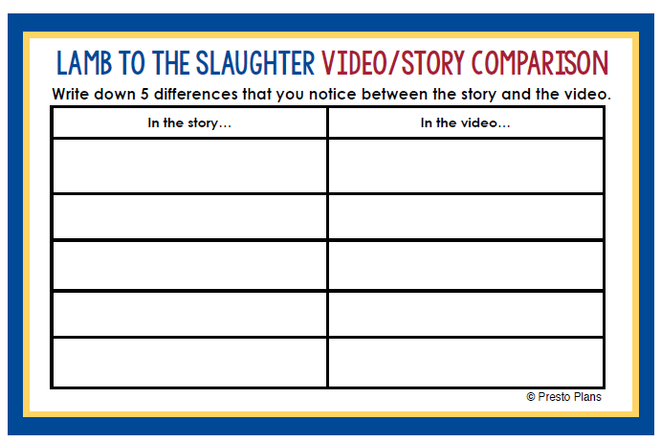
Try to complete the table:

