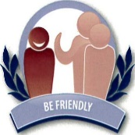The Thriftwood Code

 Be Friendly

Show Respect

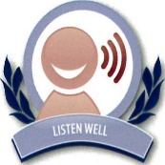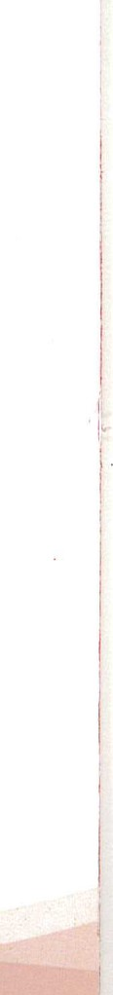

Listen well



 Work Hard

Tell the Truth 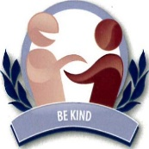



Be Kind Take Care of Property

**Home Learning**

At home, please encourage your child to be as independent to dress themselves, make basic drinks and snacks and to use purposeful communication as often as possible. As always, we expect all pupils to share a book with an adult at home as often as possible.

You can also use the following websites to support pupil learning:

-Teach Your Monster to Read

-Education City

-Purple Mash

-Oxford Owl e-books

Please contact school if you need any support to access these.

|  |
| --- |
| Thriftwood School  Swan and Wren Curriculum |
| n  On Track  Autumn Term  Mrs MacLennan and Ms Ferguson |
| School Logojpg |

**On Track**

**Parent Events**

Meet the Teacher evening

Whole School Production

**Communication and Interaction**

The pupil’s communication and interaction skills are at the heart of our curriculum in Swan and Wren. We focus on the pupil personal targets, set in his/her one plan meetings, in all areas of school life. We use each pupil’s special interests to keep him/her engaged and give a purpose for communication. During small group work, we support and encourage peer-to-peer interaction.

**English**

Focusing on storytelling and story sequencing using the ‘The Train Ride’ and ‘The Naughty Bus’.

Towards the end of the term, we will be writing lists and letters

**Phonics**- Phase 2/3 Letters and Sounds

**Maths**

Order of number

Using a numberline

Addition and subtraction

Telling the time

Using money in real life situations

**Trips**

Trips: Legoland, a local bus ride, Chelmsford Miniature Railway

We will also visit local shops and cafes to develop our road safety skills as well as experience using money in real life settings.

**Personal Development and Topic**

In our Topic lessons, we will focus on all types of transport. We use these activities to give exciting opportunities for the pupils to learn personal learning, speaking, listening, social skills and independent skills.

In PHSE lessons, we will teach the zones of regulation including, tools for regulation, as well as the Interocpetion Curriculum to develop body awareness.

We will also teach topic and PHSE lessons through Attention Autism sessions to develop pupils attention, listening, turn taking and independent working skills.