L.O: Women’s Football History Milestones in the UK and around the world

THE WIDER WORLD-HISTORY
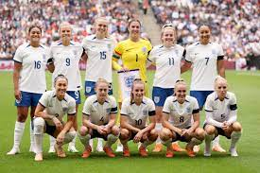
1921 | 1969
1999 | 2005
2010 | 2012
2022 | 2023

