LO – To understand a short piece of text on a simple subject
Part 5
The next day Kat and I shared the theories with dad. He took us back to the London Eye to test out some of our theories. We boarded the moving pod along with a group of eight foreign teenagers and a tired looking mum with a folded-up buggy, her baby and her two older boys. The pod began to rise.
At the end of the ride a member of staff stood at the door hurrying us to come out, but Kat stood back. She crouched down by the seats to try to test the theory that Salim may have stayed on the ride. The staff member came in and shooed her out. “Theory number one has been disproved” I said.
For the rest of the day, we disproved many of the other theories. Kat picked up the list. “Only four theories left” she said. “Two, three, four and six.”
“And nine” I said. “The ninth theory is the one I was going to tell you about last night when the phone rang” I reminded her.
Kat looked interested.
“The ninth theory is that Salim never got on the Eye in the first place,” I suggested. I explained to Kat that we thought we had seen Salim get on but maybe it was just someone that looked like him.
“It’s a clever theory,” said Kat. “But it’s wrong, Ted.” Kat believed that Salim did get on the Eye.
Later that day Kat found the souvenir photo from Salim’s London Eye ride. She decided to hand it over to the police. “We already have that photo along with the CCTV” said the Detective Inspector. She also confirmed that there were lots of other people in the pod, but not Salim.
The police also told us that a boy matching Salim’s description had been seen at 4pm yesterday at Euston station dodging ticket barriers and getting on a train to Manchester.

The London Eye Mystery Part 5 Questions
- Who took Ted and Kat back to the London Eye?

_______________________________________________

- List 2 people in the pod?

____________________________________________________

- What is Ted’s ninth theory?

____________________________________________________

- Did Kat agree with Ted’s ninth theory?

____________________________________________________

- What did Kat give to the police?

____________________________________________________

- Who had been seen at Euston station?

____________________________________________________

- Where was the boy travelling to?

____________________________________________________

Challenge Questions
- Write down 2 truths and 1 lie about the story you have read today.
________________________________________________________

________________________________________________________

________________________________________________________

- Draw a picture to show your favourite part of today’s story.

- Highlight any describing words (adjectives) in your chosen colour.
- Highlight any punctuation marks in a different colour.

- Write 1 question that you would like to ask your chosen character.
Character _________________________

____________________________________________________

____________________________________________________
LO – To punctuate sentences
Below are some sentences from the story that you have read. Can you add punctuation?
1) the next day Kat and I shared the theories with dad He took us back to the london Eye to test out some of our theories
2) at the end of the ride a member of staff stood at the door hurrying us to come out, but kat stood back
3) for the rest of the day, we disproved many of the other theories. Kat picked up the list. “Only four theories left she said
4) later that day kat found the souvenir photo from salim’s london Eye ride. She decided to hand it over to the police
5) The police also told us that a boy matching Salim’s description had been seen at 4pm yesterday at Euston station dodging ticket barriers and getting ON a train to manchester

Write a sentence about a topic of your choice using a full stop.
________________________________________________________________

Write a question about a topic of your choice using a question mark.
________________________________________________________________

Write a sentence about a topic of your choice using an exclamation mark.
________________________________________________________________

Write a sentence about a topic of your choice using a capital letter for a name or place.
________________________________________________________________
LO – To write a short story. To join clauses with ‘and.’
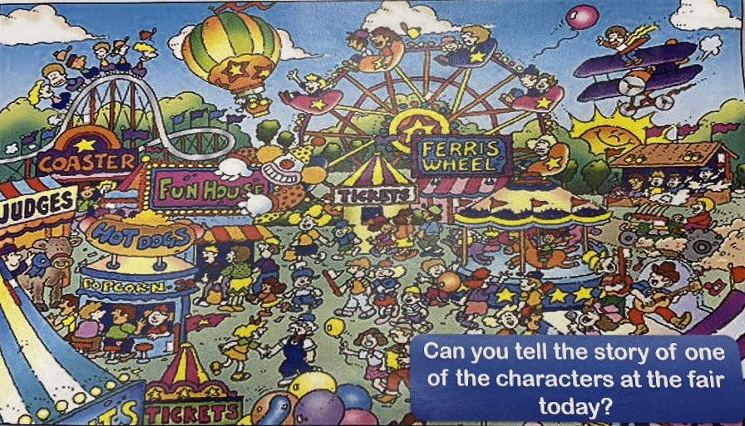

Choose one of the people from the picture. Write a story to explain why they are here.
Top tip – remember to use ‘and’ once in each sentence that you write.

