Deep Impact
Lesson 4
Near Earth Objects

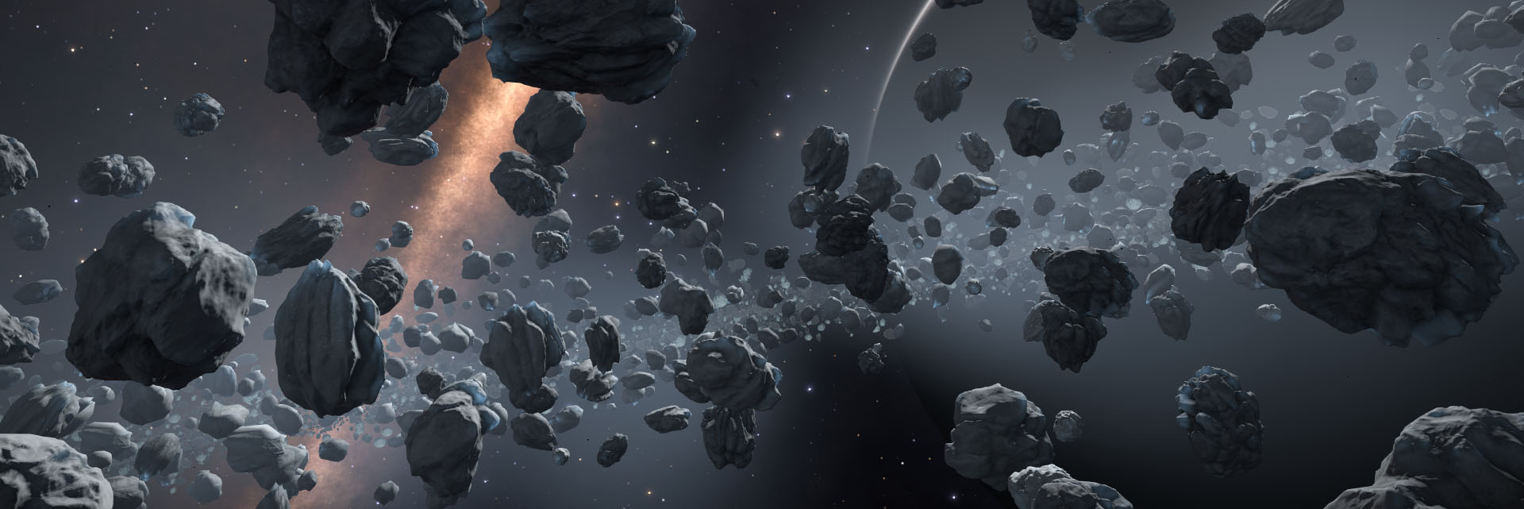

- What is a NEO?
__________________________________________________________________________________
__________________________________________________________________________________
__________________________________________________________________________________

- Who is studying NEOs?
__________________________________________________________________________________

- Why is it important to study NEOs for a long time?
__________________________________________________________________________________
__________________________________________________________________________________
__________________________________________________________________________________
__________________________________________________________________________________

- Between which two planets can you find lots of asteroids in our solar system?

_________________ and __________________

