Year 9 will learn to cook simple meals made with eggs that can be practised and replicated at home. Some of these lessons will be of a collaborative nature, working as a team to produce a healthy meal.  Other parts of the curriculum include:  - Regular individual reading, guided reading and personalized spellings for all.  - Twice weekly PE lessons  - 3 weeks of cycling  - Forest School, Outdoor Learning or journeys, weekly  - Weekly computing lessons  - Art –pupils will be exploring techniques of using colour, tone and perspective and a range of media to create artworks.  - Technology-pupils will create a personalized coat hook in the style of a character from the text Animal Farm. | The Thriftwood Code  As always, the Thriftwood Code forms a vital part of our ethos. Year 9 students are expected to model exemplary conduct.  Show respect  Listen well  Be kind  Work hard  Be friendly  Tell the truth  Look after property  This term all the students in Upper School will take part in a transition to programme, in preparation for starting year 10 at the College Site. This will involve visits to college, virtual and actual tours and some parental involvement in line with current Covid-19 restrictions. Details will follow.  COVID 19  There are rigorous social distancing and hygiene procedures in place to minimize the impact of Covid 19 throughout each day  Upper School Curriculum Summary  Thriftwood School  Slades Lane  Galleywood  CM2 8RW | Upper School Curriculum Summary  - SUMMER 2021
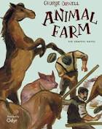  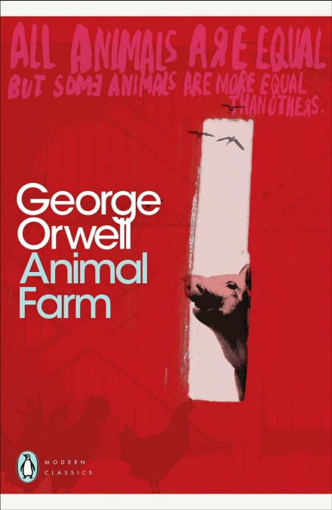  Our Literacy text this term.  Literacy  This term we will be reading and discussing ‘Animal Farm’ by George Orwell. The book and the film will both be used to explore the themes of equality.  Students will access the original text, an adapted text and watch the film to understand the perspectives of each character and to reflect on their own thoughts and opinions within our society. Through pre-teaching of vocabulary and discussion they will develop greater comprehension. They will also use ‘Colourful Semantics’ as a tool to improve writing and reading skills. Spelling, phonics and handwriting will continue to be taught in small groups. | Numeracy  We will work on building pupils’ capability to apply mathematical skills to real life tasks such as time, money, estimating and measuring. Quick recall of number facts will support their ability to use calculations and written methods effectively.  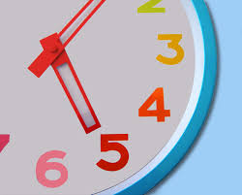  PSHCE  Sex and Relationships will be taught during this term. The focus will be on raising awareness of bodily changes and functions in relation to puberty and adulthood. Forming healthy relationships, safety and consent will all be an important part of the learning as well as information about contraception.  Covid protective measures will remain in place: hand-washing, sanitizing, social distancing, fresh air and twice weekly lateral flow testing at home. | 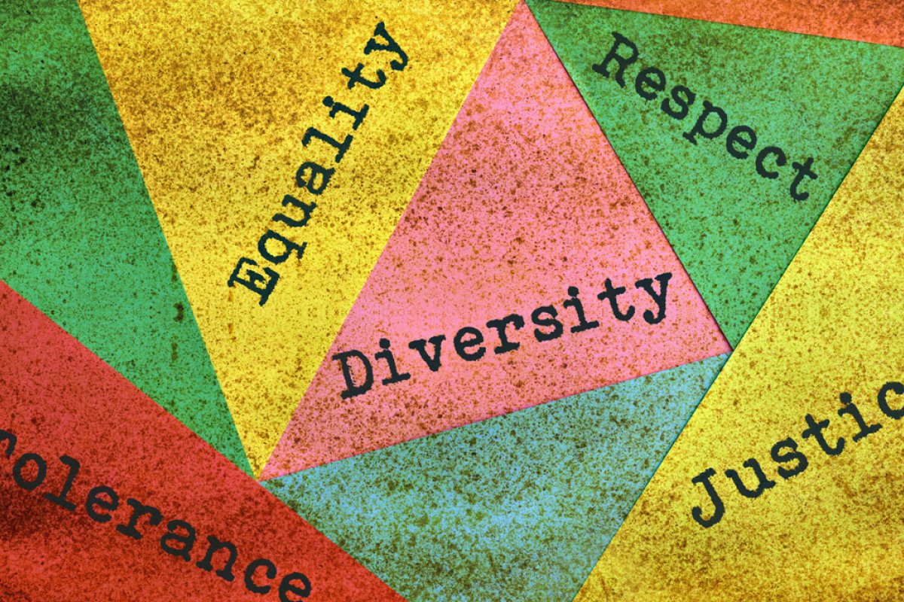  TOPIC  Pupils will work in small groups on the themes of Equality, Diversity and Justice. They will explore current perceptions and trends as well as considering stereotyping and prejudice. They will identify positive role models.  KEY SKILLS  We are continuing to work towards all students gaining as many key skills as possible in preparation for adult life, developing greater independence and organization. Your help in supporting the work we are doing in school will be vital to your child’s success, so homework is:  - key skills  - spelling and reading at home  - making their own lunches or snacks or tea  - packing and organizing their own belongings for school  - going out independently

