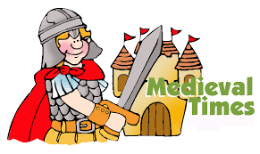
Measly Middle Ages
Autumn term 2021
ART & DT
The Bayeux Tapestry
Making a time travel helmet (Papier Mache)
Making castles using a range of materials.
Sewing – using Binca.

HISTORY
Medieval Britain timeline

Knights, life, castles, blacksmiths, Lords, Ladies, peasants, sports, The Magna Carta, War of the Roses, Kings and Queens of Medieval Britain

Educational Visit to Mountfitchet Castle

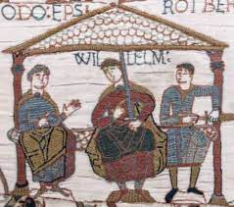
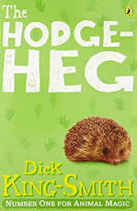
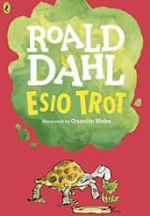
PE
Focus: Hand-eye coordination when playing games such as cricket and rounders.
PSD focus: Working as a team and showing respect to others.

ICT
Internet skills and
E-safety. Programming (floor robots), sequencing
Word processing skills, email

LITERACY: Speaking and listening skills. Experience: text development, narrative structure, reading comprehension, written text, film excerpts, drama.
Activity in response – writing, drama, grammar, punctuation
Esio Trot (Yr8), Hodgeheg (Yr7),

NUMERACY LINKS: In addition to Maths scheme of work – Time: passing of time, key times in the day, telling the time, timetables etc.

SCIENCE: Year 7: Skeletons, digestive system, diet, exercise, circulatory system.
Year 8: Habitats – classification.
Forces - Friction/Air/water resistance/Gravity.

MUSIC AND DRAMA
Tudor dancing
Rhythm, beats and timing Greensleeves
Middle School assembly singing
Whole School Christmas production

FOOD TECHNOLOGY
BRILLIANT BAKING Focus: Measuring/ kneading/ mixing with hands
Bread rolls, Cheese straws, Gingerbread people, Fancy fish/ chicken fingers, Blueberry muffins

RE and PSHCE
Me and the people around me
All about me
Zones of Regulation
Religion through the Middle Ages
Christianity – The Christmas Story

 | Literacy  End of Middle School  (min reading age 7, spelling age 7) |  | Mathematics  End of Middle School
Speaking | Use an appropriate tone  Ask a question relating to the chosen topic  State a fact  Give a description  Explain view  Give an instruction  Initiate conversation  Tell someone own name, DOB, address | Counting and Ordering | Count to 50 (One)  Count reliably up to 10 objects (Bridge)  Read, write & order numbers & numerals from 0 - >20 (Bridge)  Use ordinal language (One)
Listening | Participate actively in collaborative conversations  Follow two step instruction | Numbers and more/less | Say 1 more or less 0 to 20 (One)  Double to at least 10  Halve even numbers to 10 (One)
Reading  Word reading | Sound all graphemes  Segment and blend CCVC CVCC  Categorise words  Read first 100 HF words  Read the days of the week, months of the year and pertinent names  Work within phase 3-4 letters and sounds | Tables | Count on and back in 1’s, 2’s, 5’s, & 10’s and know the tables (Bridge)
Reading  Comprehension | Arrange alphabet  Retrieve literal information from a simple text | Bonds, facts and place value | Know & use bonds to 10 (Bridge)  Know all number pairs to 100 using ‘ten’ numbers (One)
Writing | Form Upper and lower case letters clearly  Write on the line and with finger spaces  Simple sentences  Write name, DOB  Make a list  Spell CCVC CVCC or phonetically plausible attempts  Use first 100 HFW, plausible spelling  Use capital letters and full stops | Calculation | Add & subtract two numbers under 10 (Bridge)
 |  | Time | Tell time to half past (One)
 |  | Money | Recognise all coins (One)
PSD
By the end of Middle School
Social use of language | Speak and listen on the phone  Awareness of appropriate/respectful comments  Ask for clarification if needed  Follow group instructions  Explain needs  Join in talk at mealtimes  Share interests
Behaviour and Emotional Intelligence | Recognise emotional triggers
Organisation | Tidy own bed /sleeping bag  organise belongings  Pack items in a bag to carry  Set a table
Dressing | Put on own clothes, correctly oriented, footwear on correct feet  Tidy and organise own clothes  Choose suitable clothing/ footwear for the weather  Awareness of nudity  Fasten zips  Show an awareness of own appearance
Eating | Use a knife and fork to cut and eat food  Pour drinks from a jug or bottle  Be aware of drips and spills, clean up when needed  Pass items at table and request items to be passed  Try different textures and mixtures of foods
Personal care | Use glasses and hearing aids appropriately with support  Shower and wash  Dry body and hair with a towel  Cover up effectively with a towel  Brush own hair  Tie back hair  Wash hair  Apply deodorant  lock and unlock a toilet door confidently  Put on a plaster
Safety skills | Identify safety devices such as exits and extinguishers  Cross road safely with support  Share online concerns with adult
Travel | Travel on a school bus  Travel to a familiar location with adult support  Use appropriate behaviour in outside contexts
KEY SKILLS DOCUMENTS FOR MIDDLE SCHOOL COMBINED

