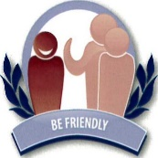
The Thriftwood Code
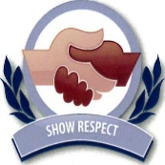
Be Friendly

Show Respect
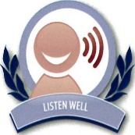

Listen well
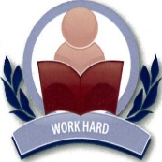

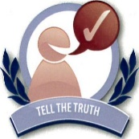
Work Hard

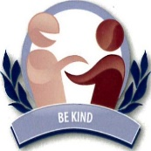
Tell the Truth
Be Kind Take Care of Property

Home Learning
We all hope we have seen the last of long term home schooling. However, if your child is required to isolate we will be providing home learning packs as well as using online platforms to deliver home learning.
At home, please continue to hear your child read as well as encourage them to read numbers/signs in the community, write shopping lists and cards to family.
As lockdown eases, it is also important to start giving your child experience in the community once again. Visit parks, playgrounds, cafes, and the supermarket to help teach them how to stay safe in the community and to follow social distancing rules

Thriftwood School
Primary Curriculum
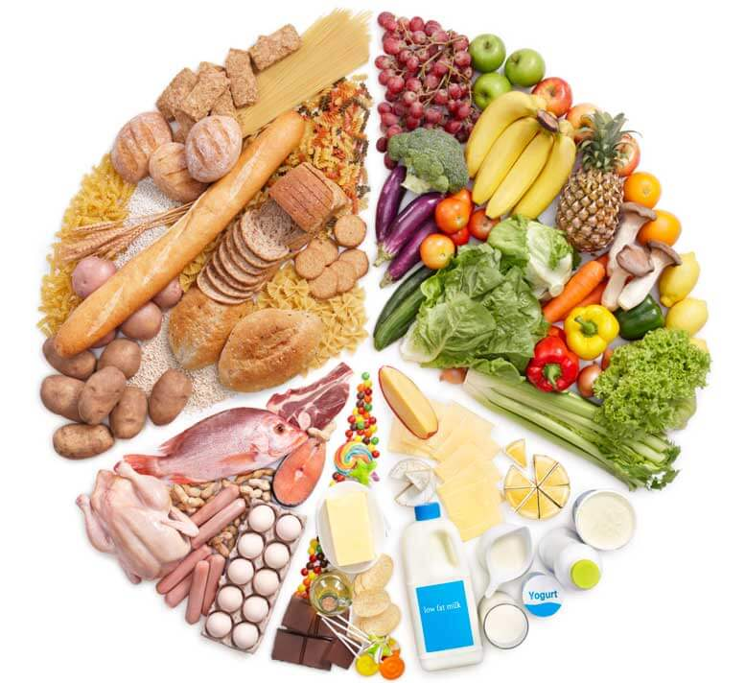
n
Keeping Healthy
Summer Term
Mrs Green, Miss Burchett, Ms Huson and Mrs Sheffle
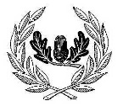

English
Robin- Non-fiction; writing lists, instructions and labels.
Puffin-'Flabby Cat and Slobby Dog' by Jeanne Willis and Tony Ross; retell the narrative, structuring sentences and choosing interesting vocabulary and punctuation.
Kingfisher- Adapted Fairy tales; reading comprehension while reading stories with a message about keeping healthy.
PHSE
Friendships
Growing and Changing

Maths
Money
Addition and Subtraction
Estimating, measuring and solving practical problem involving weight
Real life problem solving
Keeping Healthy

Science and food tech
Human Body
Healthy lifestyle
Making good food choices

Trips and Visitors
Local walks and park visits
Colchester Zoo
Walton Beach

PE
All Primary classes will have Gymnastic and Athletics sessions this term. Robin will focus on following instructions and will practise their throwing skills. Puffin and Kingfisher will be working on running, jumping, throwing and catching skills as well as their agility in Gym.
Kingfisher will also develop their team work skills in their PE lessons
All pupils will have a series of cycling lessons with David Skinner from Little Wheelers.

Parent Events
Family picnic Sports day
(covid permitting)

Personal Development
We teach personal learning skills such as team work, co-operation, following instructions, independence and learning from mistakes in all areas of school life. This term we will be focusing on independent learning skills and staying safe inside and outside of school. As we go on more community visits, this will include road safety and awareness of strangers.

