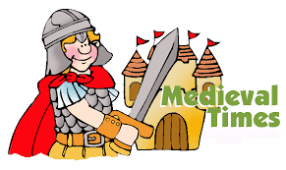**Measly Middle Ages**

**Dove and Woodpecker - Autumn term 2021**

**PSHCE**

**WORLD AROUND ME - RE**

Me and the people around me

All about me

Zones of Regulation

Religion through the Middle Ages

Christianity – The Christmas Story

**CREATIVITY - ART & DT**

The Bayeux Tapestry

Making a time travel helmet (Papier Mache)

Making castles using a range of materials.

Sewing – using Binca.

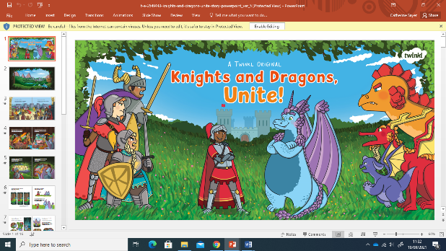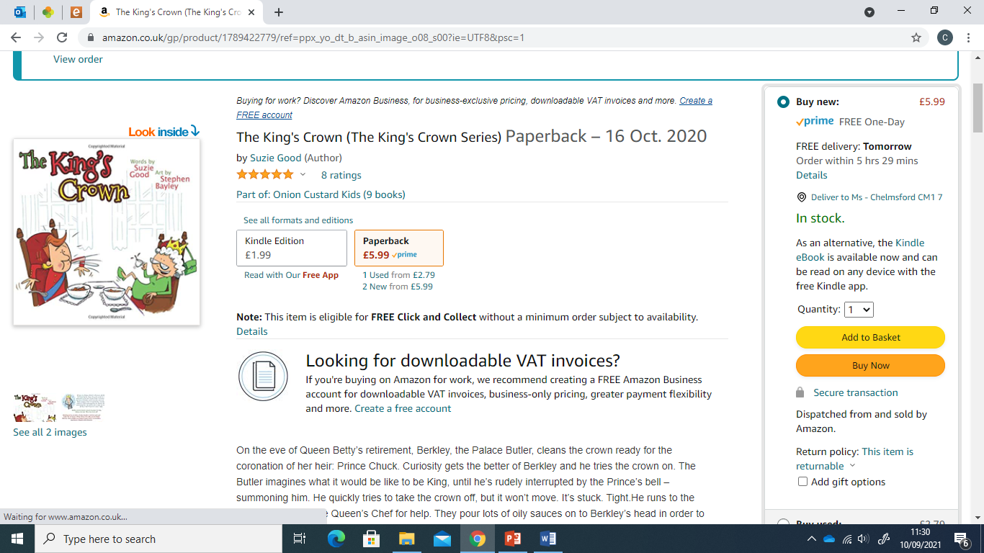

COMMUNICATION AND COGNITION - LITERACY: Speaking and listening skills. ***Experience***: text development, narrative structure, reading comprehension, written text, film excerpts, drama.

***Activity in response*** – writing, drama, sentence construction, phonics and spelling, sequencing.

The King’s Crown, Knights and Dragons Unite!

COGNITION - NUMERACY LINKS: In addition to Maths scheme of work – Time: passing of time, key times in the day, telling the time, timetables etc.

COGNITION/WORLD AROUND ME - SCIENCE: *Year 7:* How our body’s work – skeletons, the heart, diet and exercise

*Year 8:* Habitats – classification.

**PHYSICAL AND SENSORY DEVELOPMENT**

Focus: Hand-eye coordination when playing games such as cricket and rounders.

PSD focus: Working as a team and showing respect to others.

Mindfulness/relaxation

**COMMUNICATION - ICT**

Internet skills and

Online Safety,

Programming directions.

**COGNITION - FOOD TECHNOLOGY**

Super Snacks

E.g. Sandwiches and toasted sandwiches, baked beans on toast, healthy fruit snack recipes, pasta, jacket potatoes and fillings.

**CREATIVITY- MUSIC AND DRAMA**

Tudor dancing

Rhythm, beats and timing Greensleeves

Middle School assembly singing

Whole School Christmas production

**WORLD AROUND ME – LEISURE AND CARE OF LIVING THINGS**

Forest School – outdoor learning

Community – local trips incorporating life skills such as social communication, money skills, keeping safe in the community.

**WORLD AROUND ME - HISTORY**

Medieval Britain timeline

Knights, life, castles, blacksmiths, Lords, Ladies, peasants, sports, The Magna Carta, War of the Roses, Kings and Queens of Medieval Britain

Educational Visit to Mountfitchet Castle