Maths Level – Group 1 (Entry Level 1/2)
Topic : Time and Date
Aim: Read 12-hour digital clocks in hours/Read 12-hour analogue clocks in hours /State how many days are in a week. Name and order the days of the week/Order events of a typical day.
Session 1 : | Length of session: 30 minutes
Aim of session : To read analogue clocks in hours.
Important information:

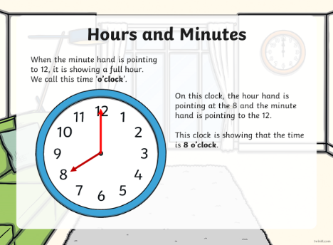
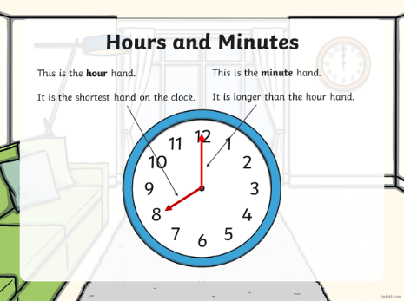
This kind of clock is called an analogue clock.

Activities:
Warm up: ‘O’clock match up activity. Look at the time each clock is showing and using the cards at the bottom, cut out the correct time and stick it in the box. The first one has been done for you as an example.

Main activities:
Activity 1: Look at clock faces and write the time it is showing on the line beneath it. The first one has been done for you as an example.

Activity 2: Look at the time written each clock face and draw the hands on the clock to show this time.

Feedback: Email the completed work to the college.

Discussion points with someone in your household:
Do you have an analogue clock in your house? Can you think of places where you see this type of clock?

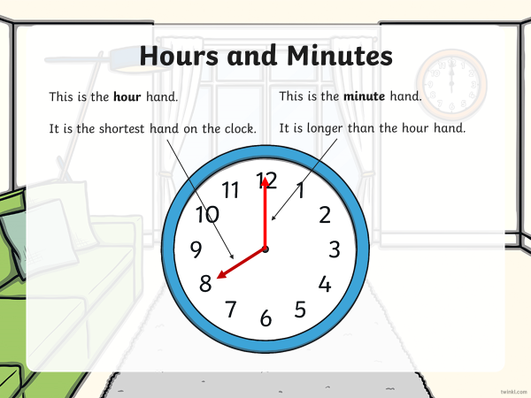
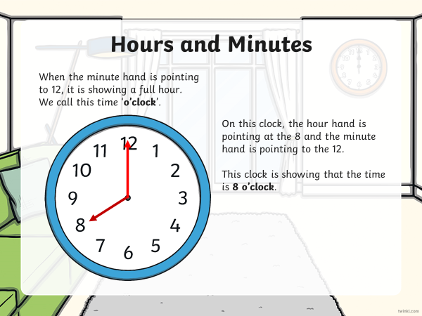
Important Information sheet

Session 2 : | Length of session: 30 minutes
Aim of session : To read digital clocks in hours.

Important information:

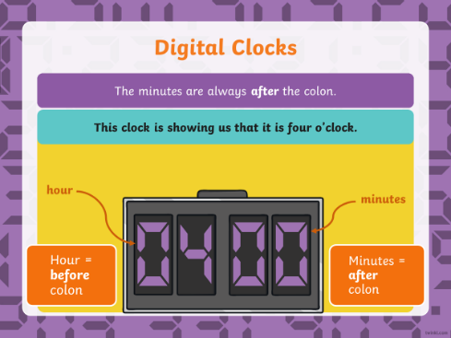
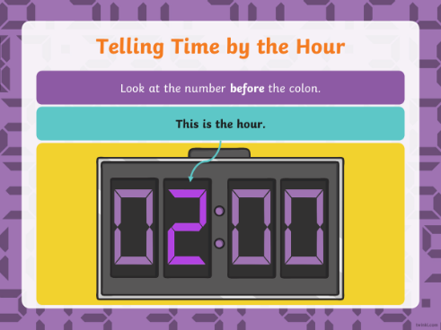

Activities:

Activity 1: Analogue to digital: Look the time written underneath each digital clock and write it in the clock. The first one has been done for you as an example.

Activity 2: Digital to analogue: Look at the time shown on the digital clocks and write it in the box underneath. The first ne has been done as an example for you. (Try to use the written form of the number e.g., Twelve O’clock rather than 12 O’clock.

Activity 3: Converting Digital clock to analogue: Look at the digital clocks and draw the hands on the analogue clock beneath it.

Feedback: Email the completed work to the college.

Discussion points with someone in your household:
Do you find it easier to tell the time from a digital clock than an analogue clock? Where do you see this type of clock most often?
Maths Level – PINK GROUP Lower (Entry Level 1/2)
Topic : Time and Date

Maths Level – PINK GROUP Lower (Entry Level 1/2)
Topic : Time and Date
Session 3: | Length of session: 30 minutes
Aim of session : To order the days of the week. To understand today, tomorrow and yesterday.

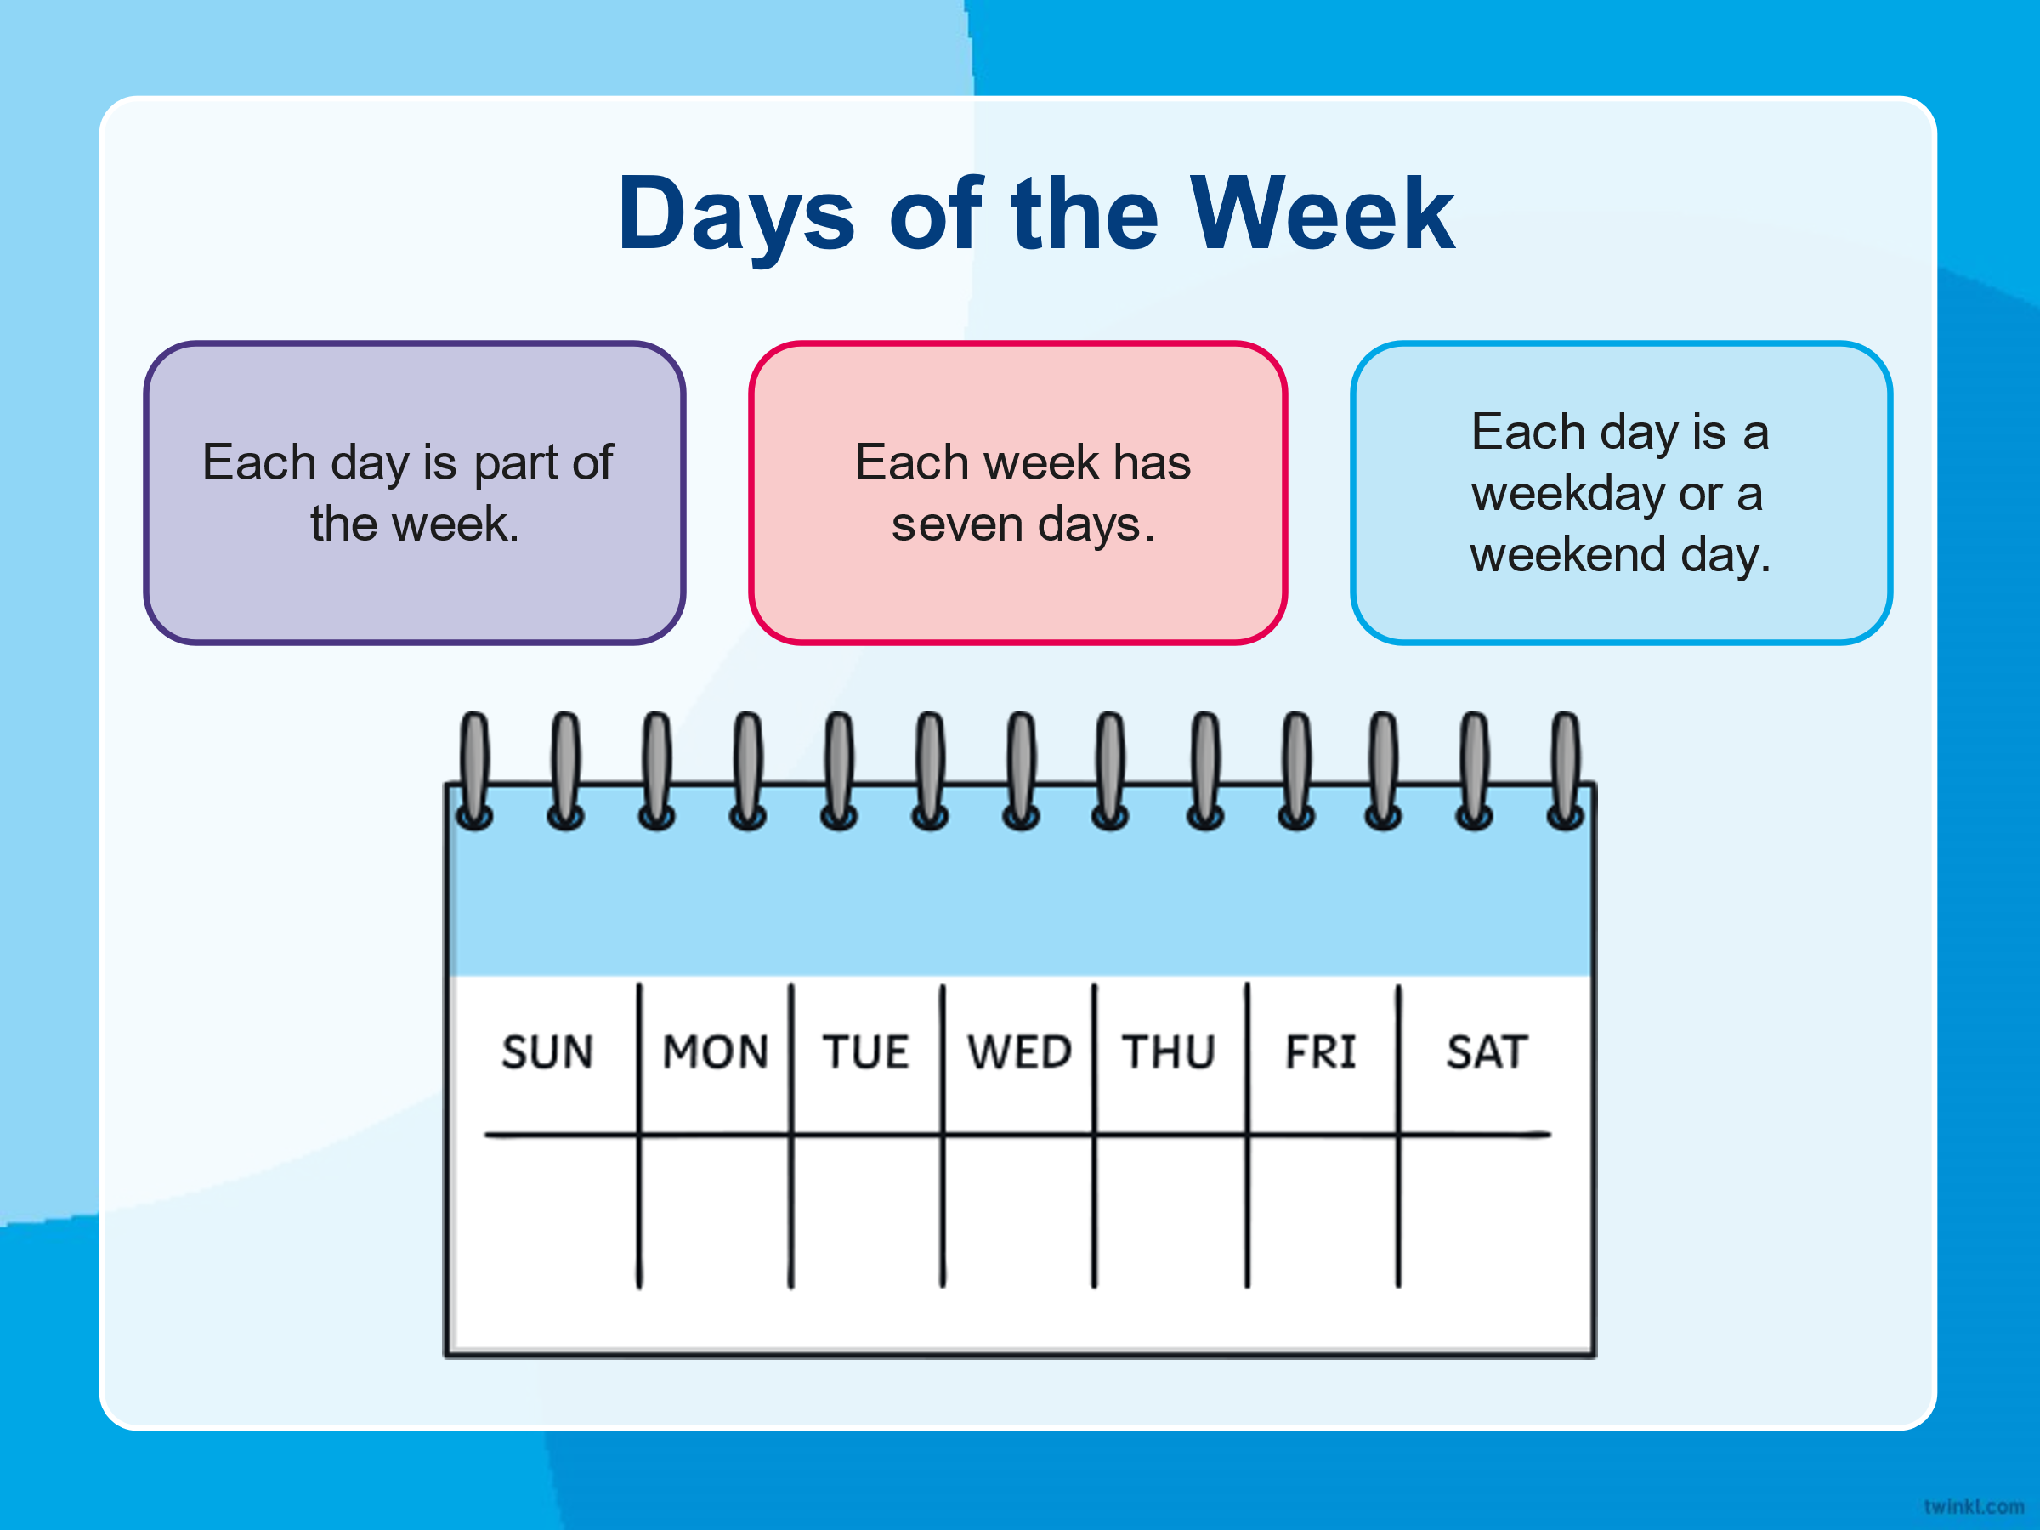
Important information:
There are 7 days in a week.

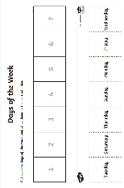
Activities:

Activity 1: Ordering the days of the week: Cut out the names of the days from the bottom of the sheet and stick them in the correct order from the first day of the week to the last.

Activity 2: Today, tomorrow, and yesterday: Look at the day written in the middle column. Use the calendar and the word bank at the bottom of the sheet to help you work out what the day would have been yesterday and what the day would be tomorrow. The first one has been done for you as an example.

Activity 3: Days of the week word problems challenge: Use the calendar at the top of the sheet to help you work out the answers to the work problems.

I have put two calendars at the top as for questions 4,7 and 8 it may be easier to see a two-week period.

Feedback: Email the completed work to the college.

Discussion points with someone in your household: What is your favourite day of the week and why?

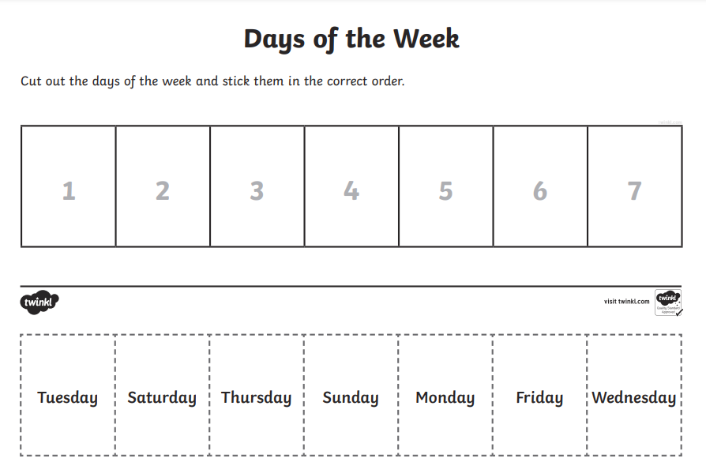

Session 4: | Length of session: 30 minutes
Aim of session : To order the events of a day.

Important information:
A day can be broken into 4 parts. The morning, afternoon, evening, and the night.

Activities:

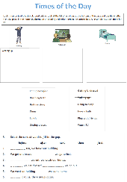
Activity 1: Times of the day activities: Look three parts of the day pictured on the worksheet Look at the list of activities at the bottom of the page and decide whether the take place in the morning, afternoon or evening and write them in the correct box. An example has been done for you.

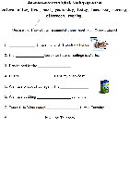
Activity 2: Sequencing events chronologically: Using the word bank at the top of the sheet, complete each sentence to describe when you do different activities during the day.

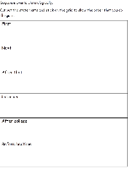
Activity 3: When do you do things? Cut out the statements and stick on the grid to show the order that you do things in.

Feedback: Email the completed work to the college.
Discussion points with someone in your household: On the bottom of the last page there are some statements you can complete about what you have done recently. Talk to your family to remember what you have been doing. (You do not need to write your answers down if you do not wish)

I go to college
I get out of bed.
I have my dinner
I watch TV or play on my computer.
I have a drink
I put my school uniform on.

Example: Yesterday I played with Olivia at playtime.
Complete a sentence of your own for the following words:

Yesterday I…

Today I…

Tomorrow I…

Last week I…

Tonight I…

