This data set aims to indicate the range of measures Thriftwood College employs to ensure that learners leave with the attributes and skills required to:-
- access the next point of appropriate learning/employment
- live as independently as possible
- make positive and healthy relationships
- access community based activity/leisure
Following a highly successful Ofsted (Sept 2017) it is clear that in ‘measuring what we value’, we are able to establish assessment systems and approaches that lead to better outcomes for learners.
We have recently focused on three key elements that have revolutionised our systems of measuring learner progress.
- Destination of Leavers
- Accreditation Results
- Assessment Data informing Learner Progress

- Destination of Leavers
Identifying an appropriate pathway and ensuring that students have the opportunity to develop the skills and accreditation necessary to fulfil that path, is a core purpose of the College. Leavers are provided with independent advice from IAG. Next steps towards a chosen route are clarified with learners and the programme is then designed around those outcomes. Learners success is attributed to the Course/route they are able to secure and their ability to remain on that course for a year or more.
*Year 14
Young Persons Profile |  |  | Destination
Gender | Learning Level | Learning Needs | College | Course Level
Female | Entry 2 | Developmental Delay/SLCN | Chelmsford College | Extended Learning Programme (EL)
Male | Entry 2 | SLCN | Chelmsford College | Extended Learning Programme
Male | Entry 2 | ASD | Chelmsford College | Extended Learning Programme
Male | Entry 3 | ASD | Chelmsford College | Extended Learning Programme
Male | Entry 2 | ASD (SEMH) | Chelmsford College | Extended Learning Programme
Male | Entry 2 | ASD | Harlow College | Extended Learning Programme
Male | Entry 3 | ASD | Chelmsford College | Extended Learning Programme
Male | Below Entry 1 | SLD/High needs | Chelmsford College (Special Provision) | Bespoke

*All learners in Year 14 have more complex needs and have been retained in order to gain social confidence and skills for independent living. They have experienced a non-accredited programme in their final year.

Year 13
Young Persons Profile |  |  | Destination
Gender | Learning Level | Learning Needs | College/Work Placement | Course/ Level
Male | Level 1 | SLCN | Chelmsford College | (EL)
Male | Entry 3 | ASD | Chelmsford College | (EL)
Male | Level 2 | ASD | Apprenticeship in Warehousing | Paid Employment
Male | Level 1 | ASD | Chelmsford College | ICT Level 1
Male | Level 1 | SLCN | Employment – Trainee Gamekeeper | Paid Employment
Female | Entry 3 | SLCN | Chelmsford College | (EL)
Male | Entry 3 | ASD | Chelmsford College | (EL)
Female | Level 2 | ASD | Chelmsford College | Health and Social Care Level 1
Male | Level 1 | ASD | Chelmsford College | ICT Level 1
Male | Entry 2 | SLCN | Chelmsford College | (EL)

Year 12
Young Persons Profile |  |  | Destination
Gender | Learning Level | Learning Needs | College | Course Level
Female | Level 1 | ASD | Writtle | Equine Apprenticeship Level 1
Male | Level 2 | ASD | Chelmsford College | ICT Level 1
Male | Level 2 | ASD | Chelmsford College | Engineering Level 1
Male | Level 2/3 | ASD | Chelmsford College | ICT/Maths Level 2
Male | Level 1/2 | ASD | Chelmsford College | Media Level 2
Female | Entry 3 | ASD/SEMH | Bespoke providers | Entry 3

Year 11
Young Persons Profile |  |  | Destination
Gender | Learning Level | Learning Needs | College | Course Level
Male | Level 2 | ASD | Chelmsford College | Engineering Level 1
Notes
- 100% of Leavers from Thriftwood College move on to a new College placement or employment
- Students who have achieved Level 2 Qualifications consistently are placed on Level 1 courses by mainstream colleges
- Focusing on core subject accreditation has improved outcomes for leavers in being able to access mainstream courses (even if at a lower level than the College deems appropriate)
- Out of 35 leavers 2016/17 33 remain in FT Education

- Accreditation Results 2017/18

Comparative Data (passes)  KS4 and 5 | English FS L1 | English FS Level 2 | Maths (FS) L1 | Maths (FS) L2 | Maths Entry L | GCSE English | GCSE Maths | A Level Maths
2016/17 | 10 | 1 | 2 | 1 | 6 | 0 | 1
2017/18 | 8 | 2 | 9 | 2 | 12 | 3  Grades  5 =B  4 =C  2 =E/F | 0 | 1 (First year of 2)

Comparative Data (passes)  KS4 Only | English FS L1 | English FS Level 2 | Maths (FS) L1 | Maths (FS) L2 | Maths Entry L | GCSE English | GCSE Maths
2016/17 | 3 | 2 | 2 | 1 | 6 | 0 | 0
2017/18 | 5 | 1 | 2 | 0 | 11 | 0 | 0

Overview of Results
- 83 students were entered for 331 different forms of accreditation including AQA Unit Awards, particularly for Work Linked Learning.
- A focus on the provision of high quality English and Maths has shown increased passes at Level 1 Maths and achievements for more able ASC learners have increased in both English and Maths.
- LAC students perform in line with peers
- Gender, Ethnicity and provision of FSM are not, according to this year’s data, major factors impacting on outcomes for learners.
- A conscious decision to reduce accreditation at Key Stage 4 below Functional Skills Level 1 has been beneficial.

AQA Unit Awards
Overview
- AQA Unit awards have been introduced to ensure that learners receive awards for their work across a wide spectrum of activities. All students are entered in the same way as they are for more exam based learning. They have high value and indicate the range of skills acquired by learners.
- Assessment Data measuring Individual progress
The College has committed to two highly innovative ways to track progress in our learners:-
- Use of a sophisticated assessment of personal development using PLTS ( Personal Learning and Thinking Skills) Designed and Strategically led by Jon Hutchings Deputy Headteacher

- The Thriftwood College Assessment System - A personalised tracking system using Excel Designed and Strategically led by Simon Kyndt – Assessment Leader

The Rationale
Measuring Individual/cohort progress has been a perennial problem for those working with SEN students. Firstly assessment has historically often attended to small next steps development with an assumption that carrying on that trajectory will ultimately align itself to mainstream development at a later stage. It is also quite understandably heavily weighted towards the core skills of literacy and numeracy.
The problem is that it often ignores a student’s understanding of the world and where they sit in the scheme of things. In reality SEN students are in, as Bronfenbrenner’s Model (1979) describes, a ‘Microsystem’, which may be termed as a ‘bubble’ of their individual, family, peer, school, and health needs. This bubble is their and generally their parents refuge and one that can be quite comfortable to live in and serves to guard against the realities of the wider context of the future and other influences, the ‘Exosystem’. Being able to negotiate and be prepared for a different wider environment other than the immediate context must be the goal for our learners and parents.
As a response the College follows the ‘Preparation for Adulthood’ framework in all aspects of its work and also aims to strengthen the skills required to be able to function beyond the home and College environment.
Measuring Progress with PLTS – System Designed and Developed by Jon Hutchings
In measuring PLTS we have found that students need to become ‘Effective Participators’ in order to progress with their Personal Development. The system in place measures their progress and can identify gradual improvements or otherwise as follows:-
Therefore with one year of data collected at two points, we know that :-
- 65 students made progress in personal development
- 40 remained the same or appeared to have gone backwards
- Using a rating system developed in line with Coventry University the range of development Outstanding progress is determined by an increase of 0.8 – 1.00 Good progress is 0.5- 0.8
- These values have little meaning until more data is collected and teachers develop more consistent ways of making judgements however we are confident that this system will enable us to identify how to support learners in a more targeted way.
The Centralised Assessment System (CAS) – Designed by Simon Kyndt
Rationale:
This form of assessment is continuous rather than summative. It allows teachers to see where the students are on a weekly basis. It gives the opportunity to the students to reflect on their own learning. The data collated is vast. Not only do we collect subject specific data, we can also integrate gender, SEN profile, and AR outcomes. This will allow us to build a comprehensive picture of each students and study the key performance indicators.
CAS also allows us to look at specific student groups and identify areas that need intervention. CAS was designed to monitor and report on student progress throughout the year and from year to year.
We have focused on Maths, English and PLTS. The process for the system is as follows:-
1. Subject leader to decide which success criteria really matter to our students in each subject
2. Create a user-friendly assessment spreadsheet based around these criteria for teachers to fill in, with student input, during the lessons.
3. These data are sent to the Assessment Lead in November and in May to create snapshots of student attainment.
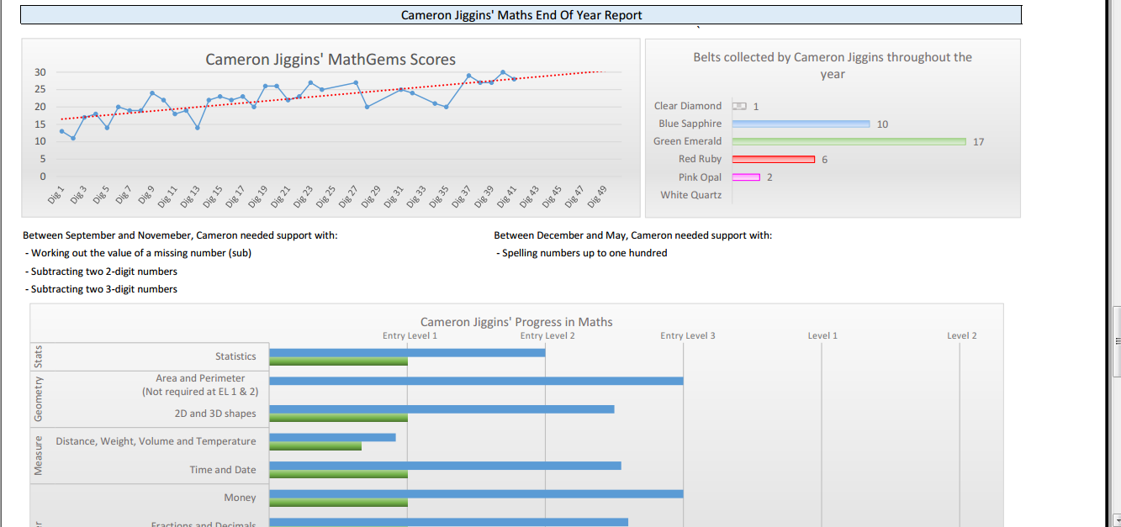
4. Reports are generated in July and sent home with the students
CAS will also provide trends and data analysis for year group cohorts and specific groups
The data available to us using this system creates enormous potential in measuring progress in learning across a range learner needs. It is all in early stages of development, however we have been given insights into the next steps for our young people as a result. Thanks must be extended to Jon Hutchings and to Simon Kyndt for their dedication and considerable abilities in these areas of innovation.

